Practical 2 Marking Scheme
Loop

Question | Description | Marks
1 | c) To iterate over a sequence of elements | 1
2 | b) To create a list of numbers to iterate over | 1
3 | B | 1
4 | sum_of_numbers = 0  # Use a "for" loop to iterate over the numbers from 1 to 5  for number in range(1, 6):  sum_of_numbers += number  # Print the sum  print("The sum of numbers from 1 to 5 is:", sum_of_numbers) | 4
5 | Any 3 of them  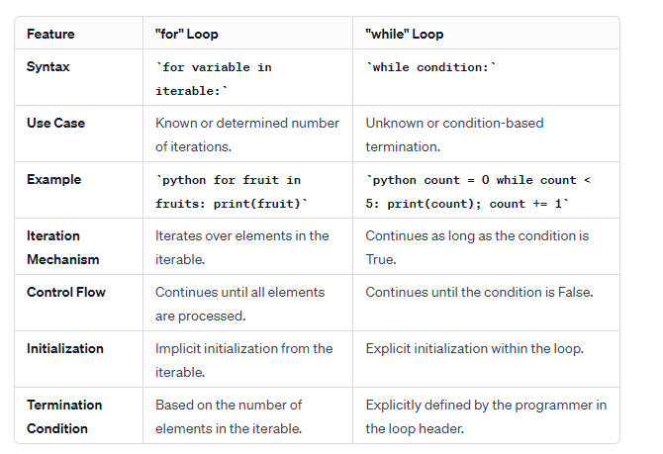 | 3
6 | b) 2 | 1
7 | c) 1 8 27 64 125 | 1
8 | b) 0 1 2 3 | 1
9 | a) 5 3 1 | 1
10 | 6: a) 3 5 7 | 1

