**Practical 2 (Graded)**

**Topic: For Loop**

Question 1:

What is the primary purpose of a "For" loop in Python?

a) To define functions

b) To create conditional statements

c) To iterate over a sequence of elements

d) To handle exceptions

Question 2:

How is the range() function typically used in a "For" loop?

a) To generate a random number

b) To create a list of numbers to iterate over

c) To check the length of a list

d) To calculate the sum of a sequence

Question 3:

Which of the following code snippets correctly prints the numbers 1 to 5 using a "For" loop?

a)

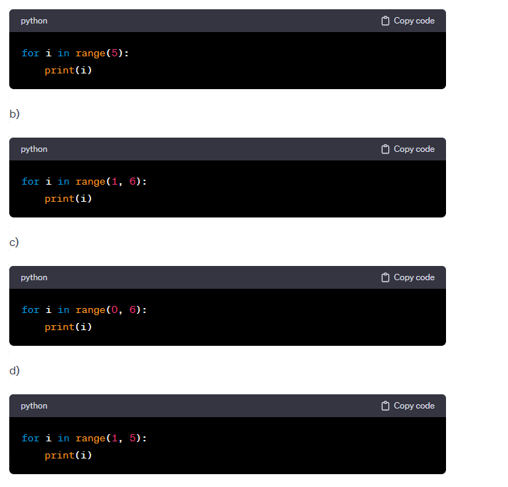

Question 4:

Write a simple Python program using a "for" loop to print the sum of numbers from 1 to 5.

…………………………………………………………………………………………………..

…………………………………………………………………………………………………..

…………………………………………………………………………………………………..

…………………………………………………………………………………………………..

…………………………………………………………………………………………………..

…………………………………………………………………………………………………..

…………………………………………………………………………………………………..

Question 5:

Explain the difference between "for" loop and a "while" loop in Python.

…………………………………………………………………………………………………..

…………………………………………………………………………………………………..

…………………………………………………………………………………………………..

…………………………………………………………………………………………………..

…………………………………………………………………………………………………..

…………………………………………………………………………………………………..

…………………………………………………………………………………………………..

Question 6:

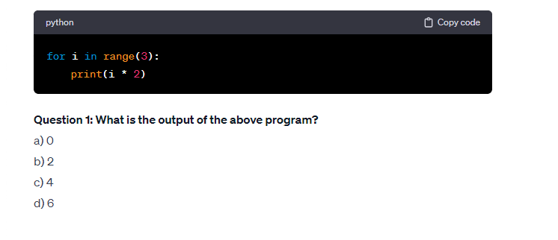

Question 7:

Question 8:

Question 9:

Question 10:

