1a  b | 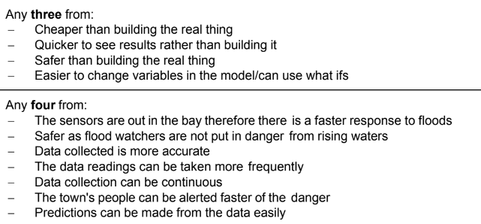 | 3  4
2 a  b | Two from:  Voice over Internet Protocol  A set of rules that enable people to use the Internet to make telephone calls/talk each other  Sends voice data in packets using IP  Two from:  Microphone  Speakers/headphones  Headset | 2  2
3 a  B  c | 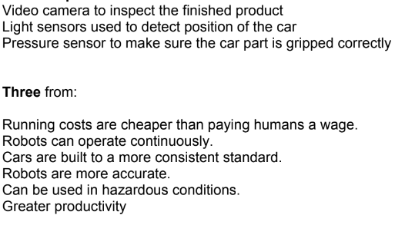  Three from:  If a change is made in the manufacturing process the robot needs to be re-programmed.  If a robot makes a mistake it will continue to make the same mistake.  Expensive to set up/maintain  Robots are not capable of performing tasks autonomously without guidance from  humans/they cannot think for themselves.  If they break down then they are difficult/impossible to repair.  If the robot breaks down the whole process stops.  The abilities of robots are suitable only for simple activities in which no major difficulties are  met. | 1  1  1  3  3

