**Week 10 Day 1 Task 1: Woking towards ARE**

**Group of 6**

* Addition 27 + 8 on the w/b.
* Identify the number, teacher showed on the bead bar . *How many more beads do you have to add to get to 30?* 3!
* *How many have you got left to add? What is 30 add 5?* Count as you move the extra beads. So 27 + 8 = 35.
* Repeat, working together to solve and record: 57 + 5, 45+ 6 and 38 + 6.

**Outcomes:**

I can add a single digit to 2-digit number, showing how to ‘bridge’ ten.

|  |  |
| --- | --- |
| Learning Outcomes/Rubrics: | |
| I can find the nearest 10 of a number. |  |
| I can find how many to reach the nearest 10 of a number. |  |
| I cana single digit to 2-digit number, showing T10. |  |

**Day 1 task 2:**

Solve sheet 1. (first 3 stops)



**Week 10 Day 1 Task 1: Woking at ARE**

**Pairs**

* Work in pairs. Spread out the calculation cards face down.
* Turn over a card each. Using a beaded line to solve the calculation, draw hops on the line to show the ‘T10’ strategy.
* Record your working using the ‘Target the 10s recording sheet’, e.g.

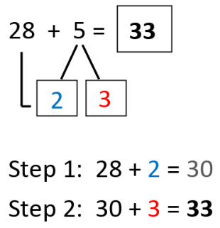

* Now swap cards and discuss each one, checking each other’s work.

To make this harder: Children use landmarked lines, so that they must apply number fact knowledge.

**Outcomes:**

I can add a single digit to 2-digit number, showing how to ‘bridge’ ten.

|  |  |
| --- | --- |
| Learning Outcomes/Rubrics: | |
| I can find the nearest 10 of a number. |  |
| I can find how many to reach the nearest 10 of a number. |  |
| I cana single digit to 2-digit number, showing T10. |  |

**Day 1 task 2:**

Solve sheet 1 (first 3 stops).



**Week 10 Day 1 Task 1: Greater Depth**

**Pairs**

* Work in pairs. Spread out the calculation cards face down.
* Turn over a card each. Using a beaded line to solve the calculation, draw hops on the landmarked line to show the ‘T10’ strategy.
* Record your working using the ‘Target the 10s recording sheet’, e.g.



* Now swap cards and discuss each one, checking each other’s work.

|  |  |
| --- | --- |
| Learning Outcomes/Rubrics: | |
| I can find the nearest 10 of a number. |  |
| I can find how many to reach the nearest 10 of a number. |  |
| I cana single digit to 2-digit number, showing T10. |  |

**Day 1 task 2:**

Solve sheet 1(complete)