Number System MS (Quiz -10 MARKS)

0 | 0 | 0 | 0 | 1 | 1 | 0 | 1

Before: 104
After : 13

One mark for each correct answer

1 | 1 | 1 | 1 | 0 | 0 | 0 | 0

Before: 15
After : 240

One mark for each correct answer

- a.
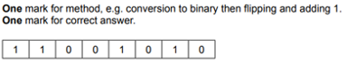
b.
