1 | Sound card  processor | 1  1
2 | 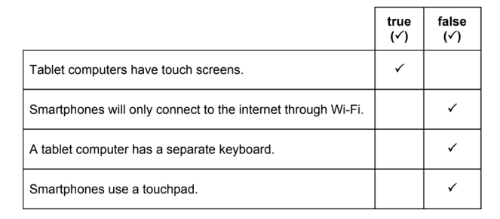 | 4
3 | 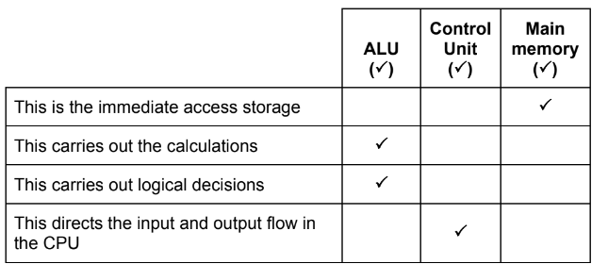 | 4
4 | 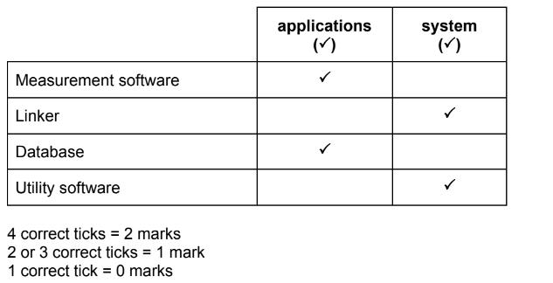 | 2
5 | Four from:  With a CLI Instructions must be typed to get a computer to carry out an  action  The user needs to remember/learn/understand the commands in a CLI  The instructions need to be entered correctly in CLI  With a CLI you have to remember the exact path and name of application  With a CLI it is more important that users understand how a computer works  With a GUI you just click on an icon  In the GUI the instructions are pre-determined  GUI is more user-friendly  GUI uses more processing power  GUI uses more memory | 4
6 | Four from:  Smartphones are more portable  Smartphones are lighter in weight  Desktops cannot be used on the move//desktops need surfaces to work on  Smartphones have integral devices//desktops have separate keyboard/monitor  Smartphones can use 3G/4G/5G communications link  Smartphones are battery powered//Desktops require a constant power supply  Desktop requires extra hardware/software  Desktop computers have a larger screen  Desktop computers have a larger keyboard  Desktop the footprint is larger  Desktops more powerful  Smartphones have more chance of being damaged/stolen as they are portable websites  Smartphones tend to use modified websites//desktop can access more | 4

