**WORKSHEET – Chapter 10**

**EFFECTIVE USE OF INTERNET**

1. A company’s employees can have access to the internet and the company intranet.

Describe the differences between an intranet and the internet.

……………………………………………………………………………………………………………………………………………..………………………………………………………………………………………………………………………………………………………………………..

…………………………………………………………………………………………………………………………………………….…………….……………………………………………………………………………………………………………………………………………………….….………………………………………………………………………………………………………………………………………….……………….………………………………………………………………………………………………………………………………………………………….………………………………………………………………………………………………………………………………………………………….………………………………………………………………………………………………………………………………………………………….………………………………………………………………………………………………………………………………………………………….………………………………………………………………………………………………………………………………………………………[6]

1. Tick which of these statements apply to a Blog, a Microblog or a Wiki.

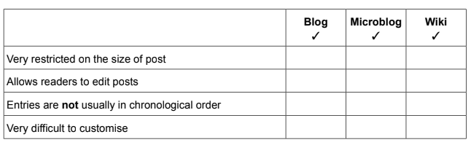

[4]