WORKSHEET – CHAPTER 10
COMMUNICATION (Marking Scheme)

Sl.No | Answers | Marks
1 | 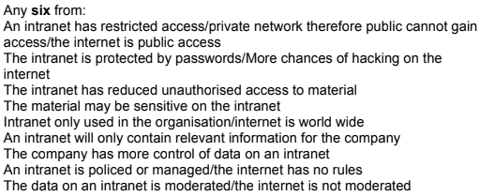 | 6
2.a | 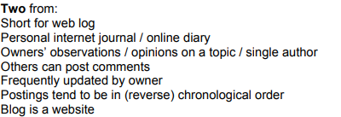 | 2
2.b | 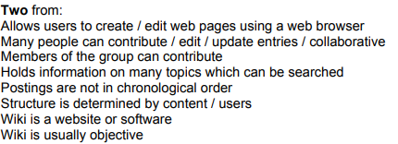 | 2

