WORKSHEET – CHAPTER 10
EFFECTIVE USE OF INTERNET (Marking Scheme)

Sl.No | Answers | Marks
1 | 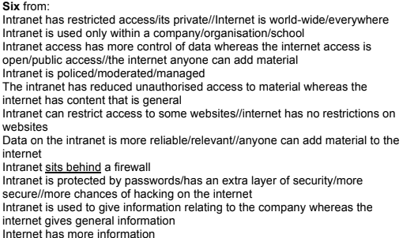 | 6
2. | 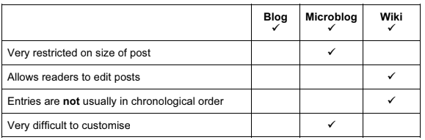 | 4

