WORKSHEET
COMMUNICATION (Marking Scheme)

Sl.No | Answers | Marks
1 | Statement TRUE FALSE  All recipients of emails can see all the recipients in the Bcc and Cc lists  Netiquette refers to need to respect other users on the internet  It is not always illegal to copy or forward email attachments | 3
2. | 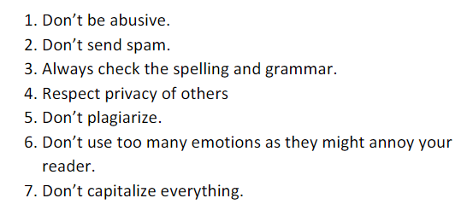 | 4
3. | 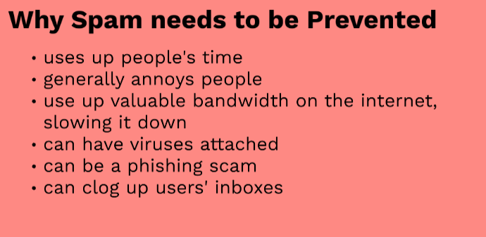 | 3

