**PRACTICAL WORKSHEET**

You work for Hothouse Design and will produce materials for the Tawara Wildlife Conservation Trust. ✓

1. Open the file **n15_3_evidence.rtf**

Make sure your name, Centre number and candidate number will appear on every page of this document.

Save this Evidence Document in your work area as **n5evidence** followed by your candidate number. For example, n5evidence9999. You will need this file later.

*The Tawara Wildlife Conservation Trust requires you to create a spreadsheet to calculate the wage bill for one week.*

*All currency values must be shown in dollars ($) with 2 decimal places. Make sure that you use the most efficient methods to do each task. Make sure that each printout fits on a single page and that the contents of all cells are fully visible.*

1. Using a suitable software package, load the file **n15_3_payroll.csv**

Examine the contents of this file and save it as a spreadsheet.

1. Use cells A19 to D27 to create a named range **Rates**

Show evidence of how you created this in your Evidence Document.

1. Merge cells A1 to H1 so they become a single cell.
2. Enter the text **TWCT – Week 14 Payroll** in this cell
3. Format this text so that it is a bold, **18** point, centre aligned, sans-serif font
4. Format this cell so that it contains white text on a black background.
5. In cell D4 enter a function to look up the pay rate from the Rates table using the pay code as the look up value and the named range Rates as the array.

*Formulae will be entered in steps 10 and 11. These will not produce results until test data is entered into cell F4*

1. In cell G4 enter a formula to calculate the pay for this employee using their pay rate and hours worked.

Select appropriate data that you can enter into cell F4 to test this formula. Enter this data in the *Data chosen column* of the test table in your Evidence Document.

Record in the *Expected column* of your test table the value you expect to see in cell G4.

Enter your test data into cell F4 and record the result in the *Actual column* of your test table.

1. In cell H4 enter a formula to display the word **Yes** if the hours worked are greater than the contract hours, display the word **No** if the hours worked are the same as the contract hours or display the word **Incomplete** if the hours worked are less than the contract hours.

Select **three** items of appropriate data that you can enter into cell F4 to test this formula. Enter this data in the *Data chosen column* of the test table in your Evidence Document.

Record in the *Expected column* of your test table the output you expect to see in cell H4.

Enter each item of test data into cell F4 and record each result in the *Actual column* of your test table for each item of test data.

1. Replicate the formulae entered in steps 9, 10 and 11 for all employees.
2. Apply appropriate formatting to all cells.
3. In cell G16 enter a function to calculate the total wage bill for this week.
4. In the centre of the header, add your name, Centre number and candidate number.
5. Save and print the spreadsheet showing the values.
6. Enter the following data in the Hours worked column:

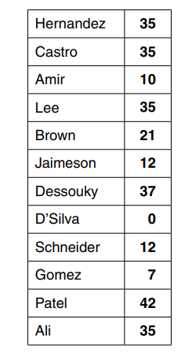

1. Save and print the spreadsheet showing formulae. Make sure the row and column headings are displayed
2. Print the spreadsheet showing the values
3. In row 1 change the text …*Week 14*… so that it becomes …**Week 15…**
4. Replace the existing data in the *Hours worked column* with this data:

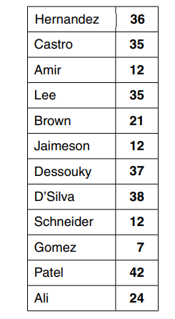

1. Print the spreadsheet showing the values
2. Sort the *Employees data* into ascending order of the employee name.
3. Print the spreadsheet showing the values.
4. Hide rows 17 to 27.
5. Search the data to extract only the employees who have worked overtime and have a Pay code starting with *F*

Show evidence of your method(s) in your Evidence Document.

1. Print the spreadsheet showing the values.