WORKSHEET MS – Chapter 10 Revision

1a  B  C  D  E  F  g | False  False  True  True  False  True  False | 1  1  1  1  1  1  1
2 a  b | 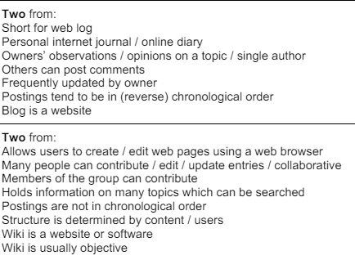 | 2  2
3 | 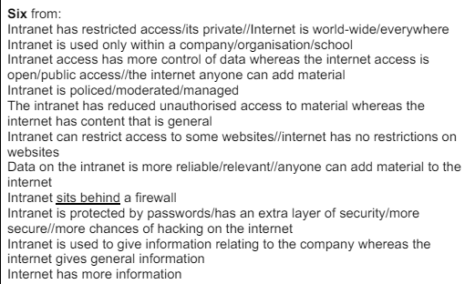 | 6
4 | 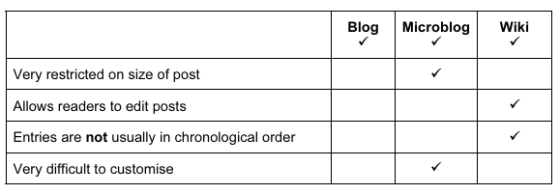 | 1  1  1  1
5a  B  C  D  E  F  G  h | Intranet  Intranet  Internet  Internet  Internet  Intranet  Internet  Internet | 1  1  1  1  1  1  1  1
6a  B  C  D  E  f | Blog  Wiki  Netiquette  Web browser  Extranets  Search Engine | 1  1  1  1  1  1
7a  B  C  D  E  F  G  H  I  J | ISP  C  E  http  e  browsing  ftp  a or b  extranet  spam | 1  1  1  1  1  1  1  1  1  1

