**REVISION WORKSHEET CHAPTER 10**

1. Indicate which of the following statements are TRUE or FALSE by putting a tick (✓) in the appropriate box.

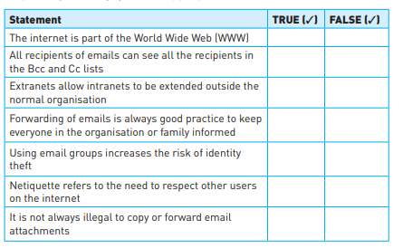 [7]

1. Describe the features of the following:
2. Blog .……………………………………………………………………………………………………………….……………………………………………………………………………………………………………….……………………………………………………………………………………………………………….……………………………………………………………………………………….[2]
3. Wiki [2] .……………………………………………………………………………………………………………….……………………………………………………………………………………………………………….……………………………………………………………………………………………………………….……………………………………………………………………………………….[2]
4. A company’s employees can have access to the internet and the company intranet. Describe the differences between an intranet and the internet.

.……………………………………………………………………………………………………………….…………………………………………………………………………………………………….……………………………………………………………………………………………………………….…………………………………………………………………………………………………….……………………………………………………………………………………………………………….…………………………………………………………………………………………………….……………………………………………………………………………………………………………….…………………………………………………………………………………………………….……………………………………………………………………………………………………………….…………………………………………………………………………………………………….……………………………………………………………………………………………………………….……………………………………………………………………………………………………………………………………………………………….[6]

1. Tick which of these statements apply to a Blog, a Microblog or a Wiki.

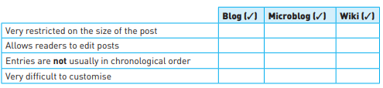[4]

1. Eight statements are given below. Indicate whether the statement is a feature of an intranet or the internet by putting a tick (✓) in the appropriate box.

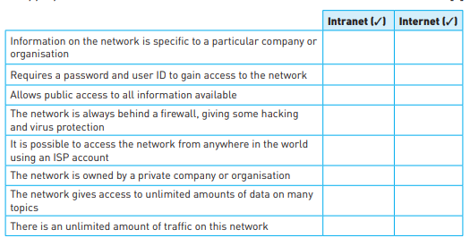 [8]

1. Six descriptions are shown on the left and six computer terms on the right. Draw lines to connect each description to its correct term.

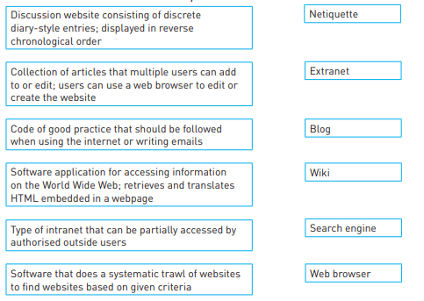 [6]

1. For each of these questions, choose the correct response from the five options given. [10]

