The structure of a neurone

This diagram shows a neurone.

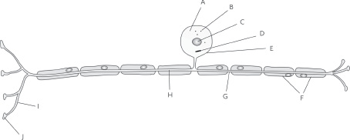

1 Is this a motor neurone or a sensory neurone? Explain your answer.

…………………………………………………………………………………………......

……………………………………………………………………………………………..

…………………………………………………………………………………………......

2 Give the letter of each of these parts of the neurone.

a the nucleus ……………………………

b the myelin sheath ……………………………

c a node of Ranvier ……………………………

d a part that picks up impulses from nearby neurones ……………………………

e the part that contains the chromosomes ……………………………

f a partially permeable membrane ……………………………

3 In what form are signals passed along the neurone?

…………………………………………………………………………………………...

…………………………………………………………………………………………...