1. Look at the picture below and answer the following questions. [3]

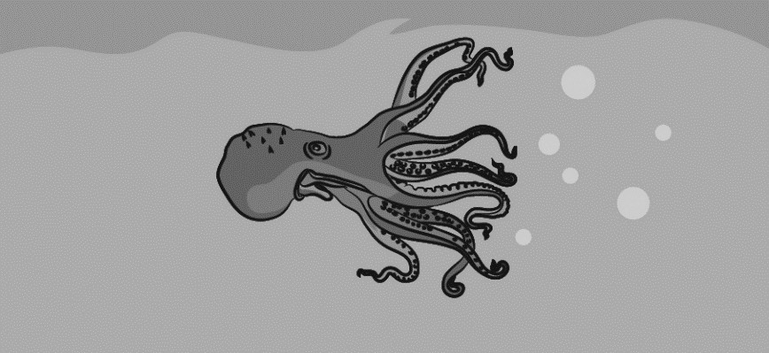

1. Draw three arrows on the picture to show the forces acting on the octopus.
2. Draw another arrow on the picture to show the force the octopus uses to move forward.
3. Label each force.
4. A learner carry out a test to compare the strengths of three magnets. He test each magnet by observing how many pins are attracted to the magnet.

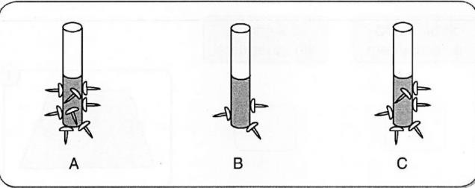

* 1. Why are pins attracted to the magnets? [1]
  2. Which magnet is the strongest? Give reason for your answer. [2]

1. The drawing shows Samir is riding his bike.
   1. What are the two forces that are trying to slow him down? [2]

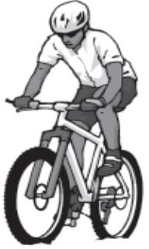

* 1. What could he do to increase his speed? [1]

1. If two forces are the same size and are in the opposite directions, they are

. [2]

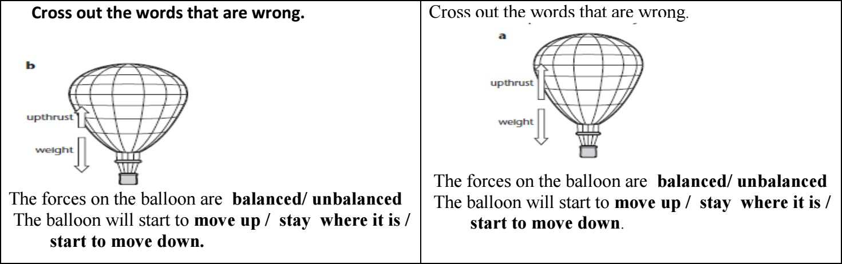

1. How does the shape of this shark help it to move quickly through the water? [1]

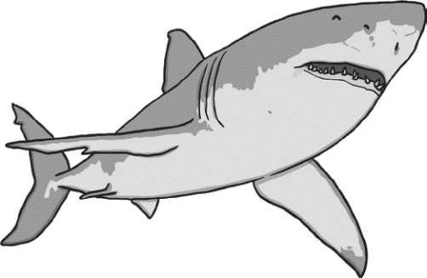

1. Label these diagrams to show the forces acting on them. [2]

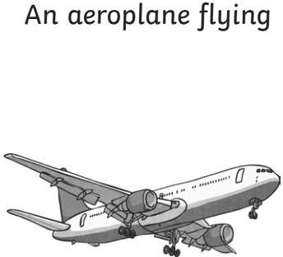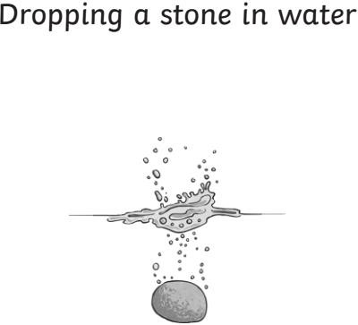

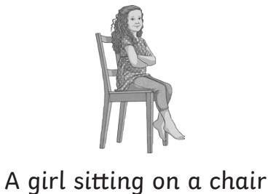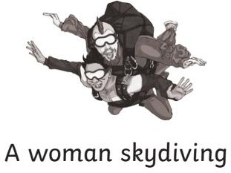

1. The following table shows the results of an investigation carried out by pupil. [5]

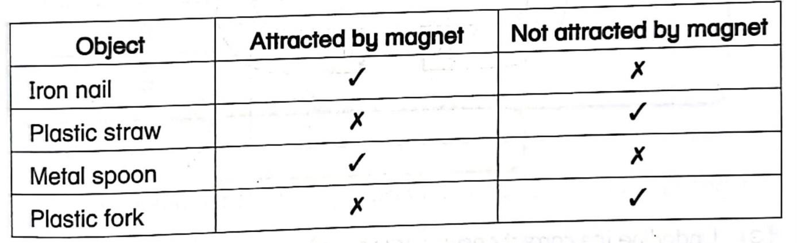

Based on the table tick the correct statement and cross the wrong statement.

* 1. All objects are attracted to the magnet.
  2. Only the iron nail and plastic fork are attracted to the magnet.
  3. Not all objects are attracted to the magnet.
  4. Only the iron nail and metal spoon are attracted to the magnet.
  5. Objects that are made from plastic cannot be attracted to the magnet.

1. Students are investigating whether the size of a parachute affects the speed in which an object falls. Here are the results.

|  |  |  |  |
| --- | --- | --- | --- |
| Size of parachute | First drop  (in seconds) | Second drop  (in seconds) | Third drop  (in seconds) |
| Small parachute | 1.26 | 1.22 | 1.24 |
| Large parachute | 2.50 | 2.56 | 2.53 |

1. Name two forces that acted on the parachute after they dropped it. [1]
2. Which parachute took longer to fall? [1]
3. Explain why one parachute fell faster than the other? [2]
4. Cars have different forces acting on them.

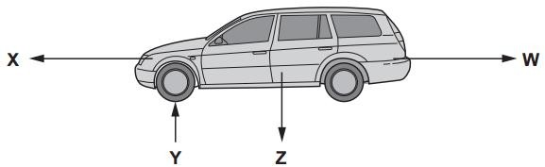

1. Draw an arrow to show the missing force on the diagram. [1]
2. Which letter shows the force of friction. [1]

_

1. Which force is shown by letter X? [1]

_

1. How does an artificial satellite manage to travel from Earth into space? [1]
2. How does an artificial satellite keep in orbit around the Earth? [1]

1. Classify the following as magnetic and non-magnetic materials in the table given below. /3

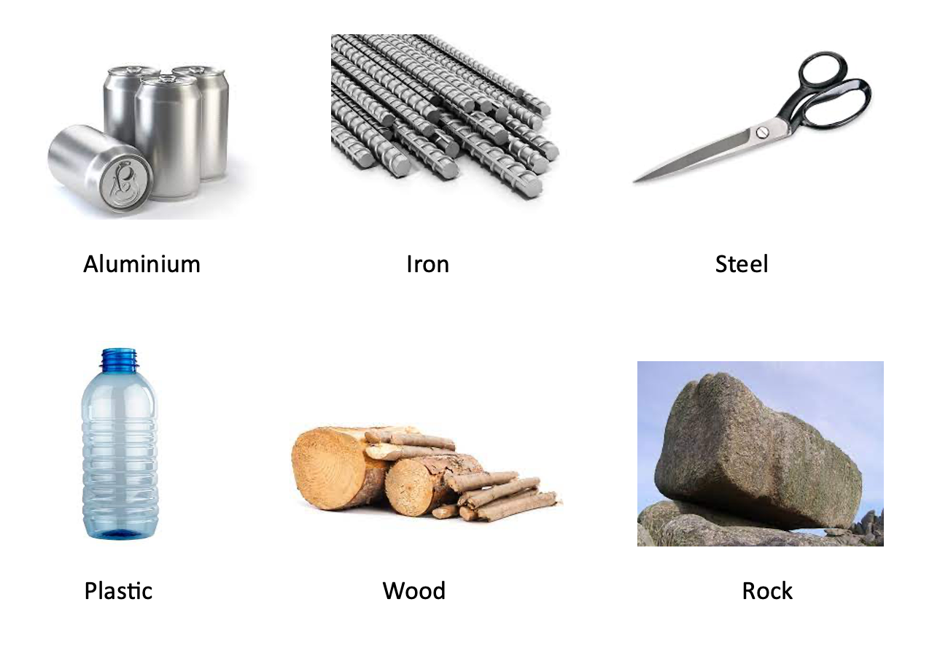

|  |  |
| --- | --- |
| **Magnetic** | **Non-magnetic** |
|  |  |
|  |  |
|  |  |

1. Draw and label a force diagram to show the forces on a moving car. /1.5

1. **Analyse the situation and write the name of the force applied. /5**
2. Alex wants his swing to go higher. What can his father do while standing at the back to help the swing go higher?

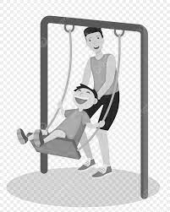

2. Tom wants to make the ball roll away from him. What force should he use to move the ball?

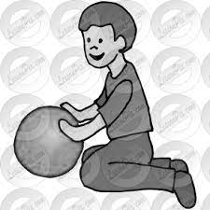

3. Emily wants to open a drawer in her room. The drawer is closed, and she wants to see what's inside. What action should Emily take to open the drawer?

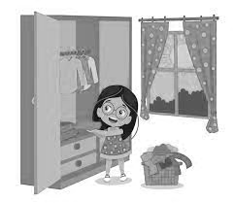

4. Daniel is leaving his room and wants to close the door behind him. What should he do to make the door shut?

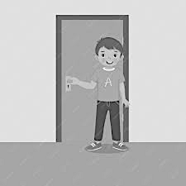

5. Emily is floating a toy boat in a pond. She wants the boat to move away from her. What can Emily do to make the boat move?

