**Marketing Mix: product and price**

**Starter activity:**

|  |  |
| --- | --- |
| **Key terms** | **Definition** |
| Brand image |  |
| brand name |  |
| brand loyalty |  |
| packaging |  |

**Development activity:**

**……………………………………………………………………………………………………………………………………………………………….**

**……………………………………………………………………………………………………………………………………………………………….**

**……………………………………………………………………………………………………………………………………………………………….**

**……………………………………………………………………………………………………………………………………………………………….**

**……………………………………………………………………………………………………………………………………………………………….**

**……………………………………………………………………………………………………………………………………………………………….**

**……………………………………………………………………………………………………………………………………………………………….**

**……………………………………………………………………………………………………………………………………………………………….**

**……………………………………………………………………………………………………………………………………………………………….**

**……………………………………………………………………………………………………………………………………………………………….**

**……………………………………………………………………………………………………………………………………………………………….**

**Support notes:**

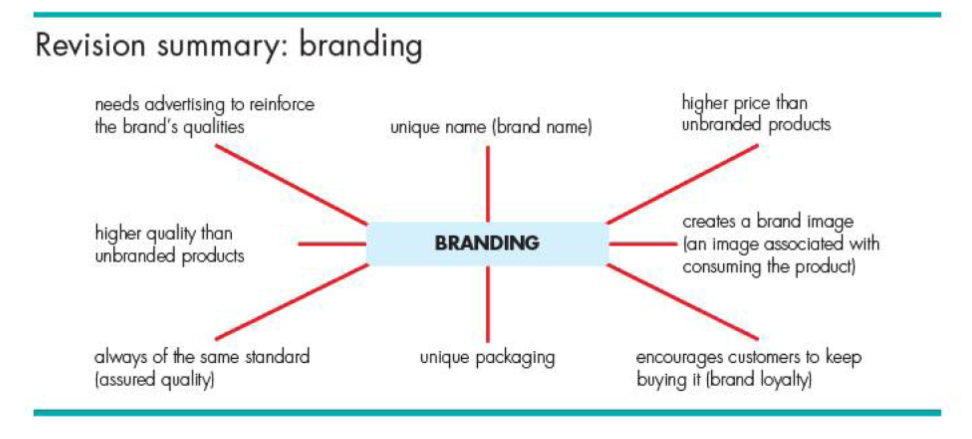

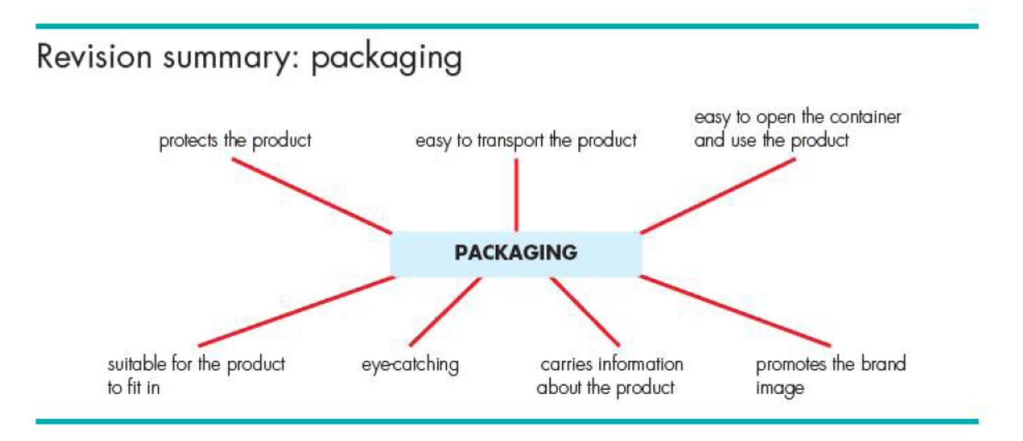

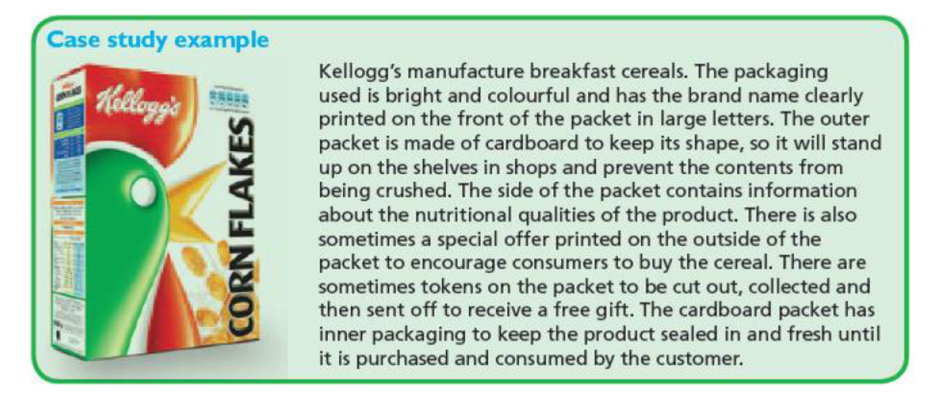

**Practice Activity:**

Write a short summary to explain the benefits of branding to a company.

**……………………………………………………………………………………………………………………………………………………………….**

**……………………………………………………………………………………………………………………………………………………………….**

**……………………………………………………………………………………………………………………………………………………………….**

**……………………………………………………………………………………………………………………………………………………………….**

**……………………………………………………………………………………………………………………………………………………………….**

**……………………………………………………………………………………………………………………………………………………………….**

**……………………………………………………………………………………………………………………………………………………………….**

**……………………………………………………………………………………………………………………………………………………………….**

**……………………………………………………………………………………………………………………………………………………………….**

**……………………………………………………………………………………………………………………………………………………………….**

**……………………………………………………………………………………………………………………………………………………………….**





























