MS-WORD

Microsoft Word is a word processor developed by Microsoft. It was first

released in 1983 under the name Multi-Tool Word for Xenix systems. MS

Word is a popular word-processing program used primarily for creating

documents such as letters, brochures, learning activities, tests, quizzes and

students' homework assignments. There are many simple but useful features

available in Microsoft Word to make it easier for study and work. That's why

so many people would prefer to convert the read-only PDF to editable Word

and edit PDF in Word.

**Task 1**

**Create a make code program for the following algorithm.**

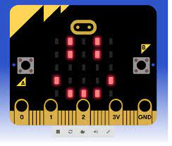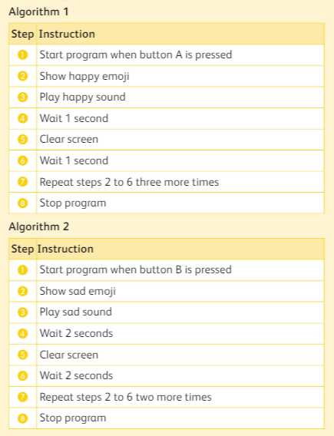

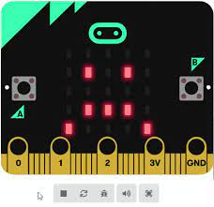

1.Open the make code from google.

2. Click on new project and assign a name.

3.Follow the above algorithm.

* Click on the Basic category in the Toolbox. Drag a show icon block into the on button A pressed block.
* In the show icon block, click on the Heart icon to open the menu. Select a Happy Face icon.

4.Follow the same steps for sad face only need to select the another icon.

**Task 2-**

**Create document about input or output of the devices in microbit.**

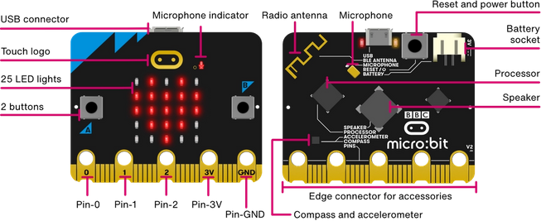

1.Open MS Word.

2.Give a heading as “Input or Output devices of Microbit”.

3.Search information about any of the topic.

4.Insert an image of microbit.

5.Mention **any four input or output devices** the devices in bullet points.

6.Save the work.

|  |  |  |  |
| --- | --- | --- | --- |
| **Rubric for Make code & MS Word** | | | |
|  | 1 | 2 | 3 |
| Open make code |  |  |  |
| Use of blocks |  |  |  |
| Relevant information |  |  |  |
| Use of Bullet list |  |  |  |
| Save the document |  |  |  |
| **Key**:   1. Needs more opportunity to develop this skill. 2. Beginning to demonstrate this skill. 3. Has achieved this skill. | | | |