1. A recipe requires 3 eggs to make 7 cookies. How many eggs will be needed to make 14 cookies?

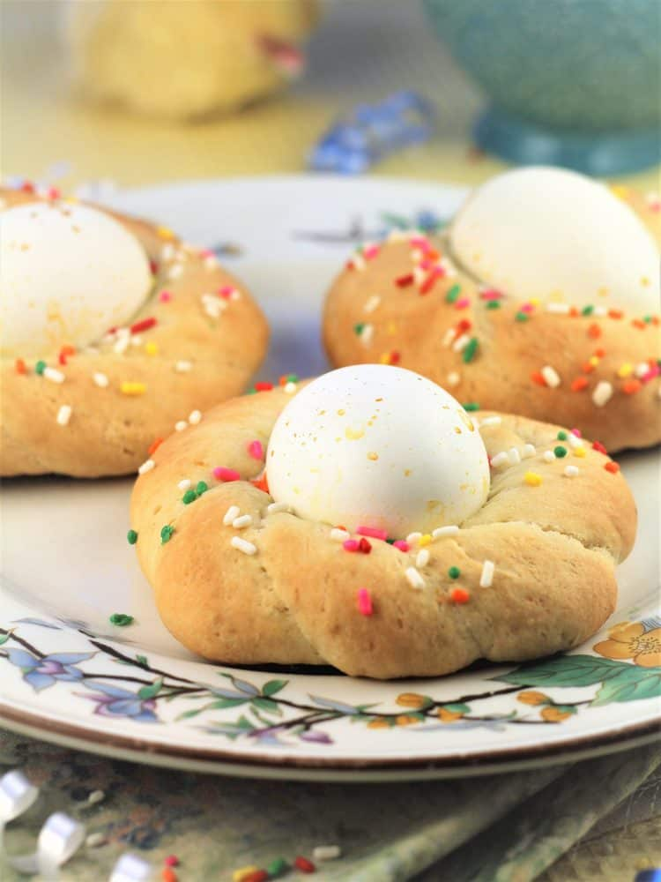

2. A bottling machine makes 60 bottles in 11 hours. How many bottles will it make in 16 hours?

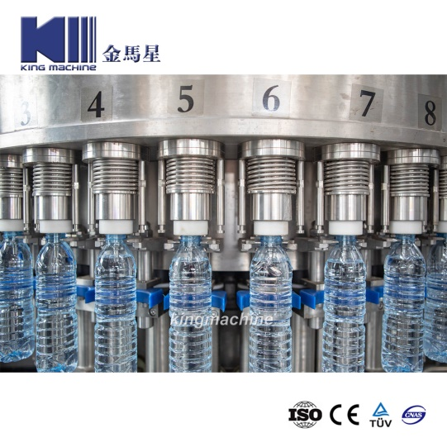

3. Steve invites six people for dinner. He wants to make Lemon Ice Cream for dessert.

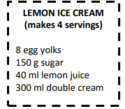

1. How many eggs does Steve need to make Lemon Ice Cream for 6 people?
2. Steve has 50 ml of lemon juice. Is this enough to make the recipe for 6 people? If no, how many more ml of lemon juice does he need?