EXIT TICKET

1. Say if these are direct or inverse proportions:

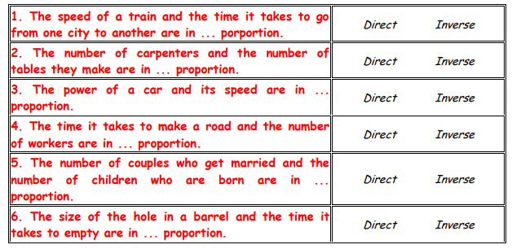

1. If 10 calculators cost £120, how much will 8 calculators cost?
2. If 5 bags of sweets contain 90 sweets in total, calculate how many sweets seven bags will contain.