# Argumentative Essay Writing

In an **argumentative essay**, your job is to make the reader agree with your opinion about a controversial topic.

You have to **(1)** state your opinion, **(2)** give reasons to support your opinion, and **(3)** argue against the opposite opinion. Overall, you must **convince** the audience that your side of the

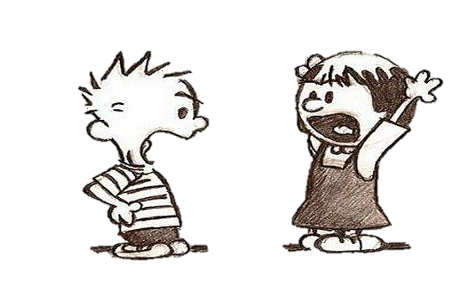

argument is correct. To convince the audience, your essay must be balanced—it must include your viewpoint and the opposing viewpoint, or **counterargument**.

Even though you are arguing only one side of an issue, you must think about what the other side would say about your opinion. After you give the counterargument, you must **refute** it by showing that it is wrong. If your essay is balanced, a reader is more likely to agree with you.

## ORGANIZATION

The most common type of argumentative essay has six paragraphs. Like all essays, it begins with an introduction and ends with a conclusion. In between are the body paragraphs where you must do three things: support your opinion, present the opposing point of view, and tell why that viewpoint is wrong.

|  |  |  |
| --- | --- | --- |
| **INTRODUCTION** | Paragraph 1 | **Hook**  **Connecting/Background Information Main Idea Statement/Thesis Statement** |
| **BODY** | Paragraph 2 | **Support 1 (first reason)**   * Explanation, detail, example * Explanation, detail, example |
| Paragraph 3 | **Support 2 (second reason)**   * Explanation, detail, example * Explanation, detail, example |
| Paragraph 4 | **Support 3 (third reason)**   * Explanation, detail, example * Explanation, detail, example |
| **CONCLUSION** | Paragraph 5 | **Repeat your thesis statement in different words Suggestion/Opinion/Prediction for the future** |

## Studying an Argumentative Essay

The following essay argues for the use of school uniforms. Discuss the Preview Questions with the class. Then read the example essay and answer the questions that follow.

***Preview Questions***

1. Did you wear a uniform when you went to school?
2. Some people believe that children are too materialistic these days. For example, they may be too interested in wearing expensive brand name clothes. What is your opinion?



