Types of Organisations

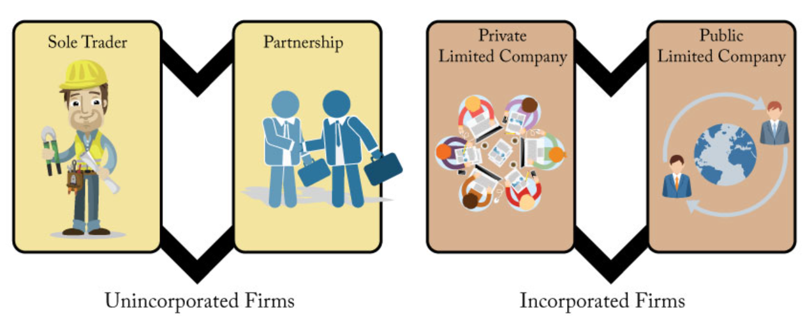PUBLIC LIMITED COMPANIES

Activity 4.2:

…………………………………………………………………………………………………………………………………………………………

…………………………………………………………………………………………………………………………………………………………

…………………………………………………………………………………………………………………………………………………………

…………………………………………………………………………………………………………………………………………………………

…………………………………………………………………………………………………………………………………………………………

…………………………………………………………………………………………………………………………………………………………

…………………………………………………………………………………………………………………………………………………………

…………………………………………………………………………………………………………………………………………………………

…………………………………………………………………………………………………………………………………………………………

…………………………………………………………………………………………………………………………………………………………

…………………………………………………………………………………………………………………………………………………………

…………………………………………………………………………………………………………………………………………………………

…………………………………………………………………………………………………………………………………………………………