**Create a pong game from the learn panel as follows:**

1. Open a new project in scratch.
2. Add the neon tunnel backdrop.
3. Add the ball and paddle sprites.
4. Add the code to all the sprites from the given algorithm

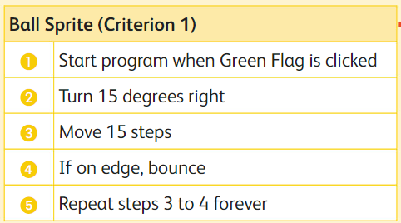

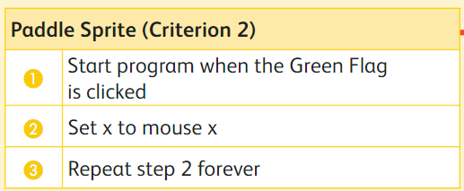

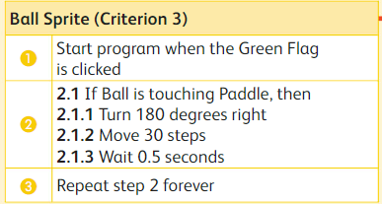

1. Run and evaluate the required result on the basis of following criteria:

|  |  |  |
| --- | --- | --- |
| **Steps** | **Criteria** | **Status** |
| 1 | The ball should move around the stage |  |
| 2 | The user should be able to control a paddle by moving a mouse pointer |  |
| 3 | The ball should bounce off the paddle |  |