**EXTENSION TASK:**

Add some more features to the game you created and test your code.

1. Add and position the **Line** sprite close to the bottom of the stage
2. Add code to these two sprites to match the algorithms below:

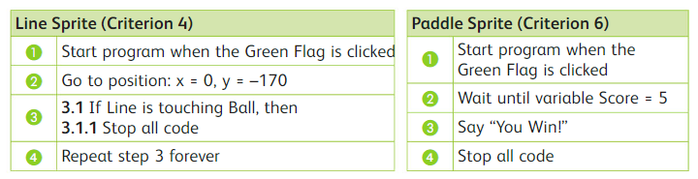

1. Amend the ball sprite code to match the updated algorithm below:

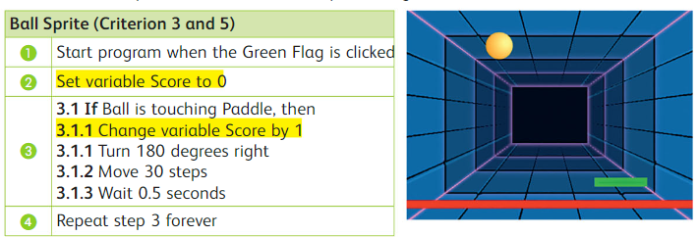

1. Which criteria below is NOT met by the code you added?
2. The game should stop if the ball hits a red line.
3. A point should be added each time you hit the **ball** with the **paddle.**
4. The paddle sprite should say “**You Win!”** When you score 10 points.