**Quiz 4 (Graded)**

**Security of Data**

1. Seven ICT descriptions are shown on the left and seven ICT terms on the right. By drawing arrows, connect each description to the correct term.

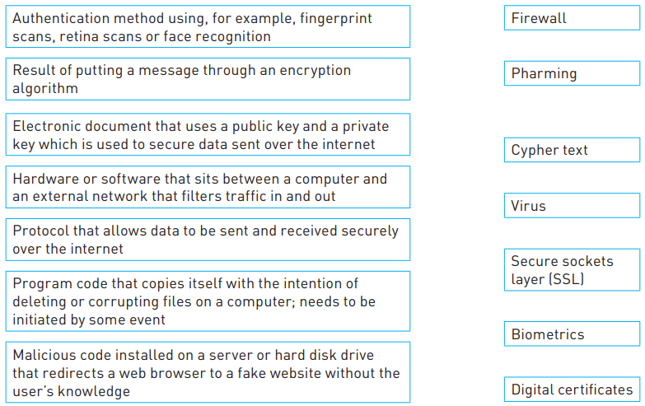 [7]



**2.**

1.Since biometric authentication uses unique characteristics for verification, they are difficult to replicate. Traditional methods, such as passwords or ID cards, are not as secure because they can be stolen or guessed easily.

2.They are quick and convenient—you don't have to remember or key in anything. They are hard to fool—particularly face, iris or voice recognition—and are potentially more secure than even a strong password.

1. A student is using a computer to access social media.

3.

A firewall can be software or hardware. It sits between the user’s computer and an external network (for example, the internet). A firewall will help to keep potentially destructive forces away from a user’s computer, by filtering incoming and outgoing network traffic. The criteria for allowing or denying access to a computer can be set by the user.