**Quiz 4 (Graded)**

**Security of Data**

1. Seven ICT descriptions are shown on the left and seven ICT terms on the right. By drawing arrows, connect each description to the correct term.

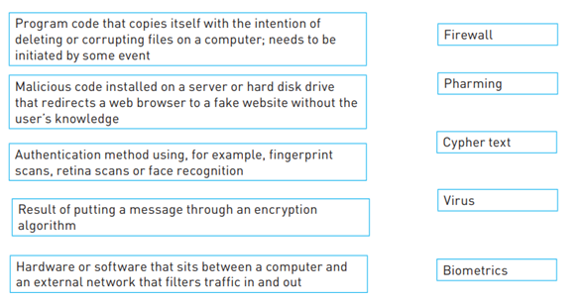 [5]

1. Explain 2 reasons why biometric authorization methods are more effective at securing computer systems when compared to user-id’s and passwords.

1 ------------------------------------------------------------------------------------------------------------------------------------------------------------------------------------------------------------------------------------------------------------------------------------------------------------------------------------------------------------------------------------------------------------------------------------------------------------------------------------------------------------------------------2-------------------------------------------------------------------------------------------------------------------------------------------------------------------------------------------------------------------------------------------------------------------------------------------------------------------------------------------------------------------------------------------------------------------------------------------------------------------------------------------------------------------------- [2]

1. A student is using a computer to access social media.

Explain how a firewall would be used to secure the data in the computer connected to the internet.

------------------------------------------------------------------------------------------------------------------------------------------------------------------------------------------------------------------------------------------------------------------------------------------------------------------------------------------------------------------------------------------------------------------------------------------------------------------------------------------------------------------------------------------------------------------------------------------------------------------------------------------------------------------------------------------------------------------------------------------------------------------------------------------------------------------------------------------------------------------------------------------------------------------------------------------------------------------------------------------------------------------------------------------------------------ ----------------------------------------------------------------------------------------------------------------------------------------------------------------------------------------------------------------------------------------------------------------------------------------------------------------------------------------------------------------------------------------------------------------------------------------------------------------------------------------------------------------------------------------------------------------------------------------------------------------------------------------------------------------------------------------------------------------------------------------------------------------------------------------------------------------------------------------------------------------------------------------------------------------------------------------------------------------------------------------------------------------------------------------------------------------------------------------------------------------------------------------------------------------------------------------------- ---------------------------------------------------------------------------------------------------------------------------------------------------------------------------------------------------------------------------------------------------------------[3]