Term: II

Session: 2023 – 2024

I. Colour the poster.

Name: Date:

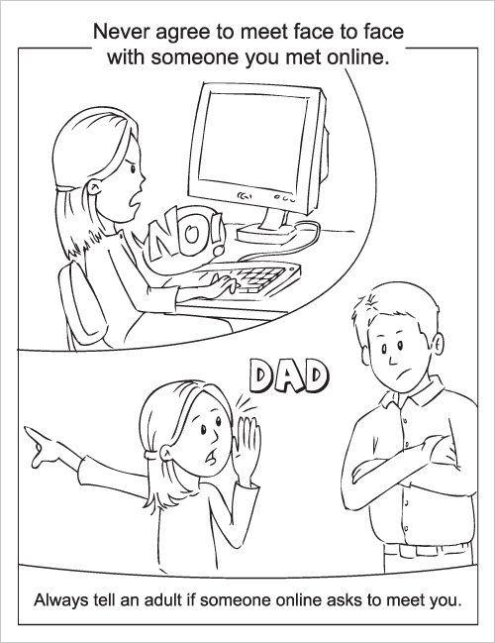

CS – Yr I

HW Worksheet

Safna