**TASK A:**

1. Open [**https://www.starfall.com/h/**](https://www.starfall.com/h/)

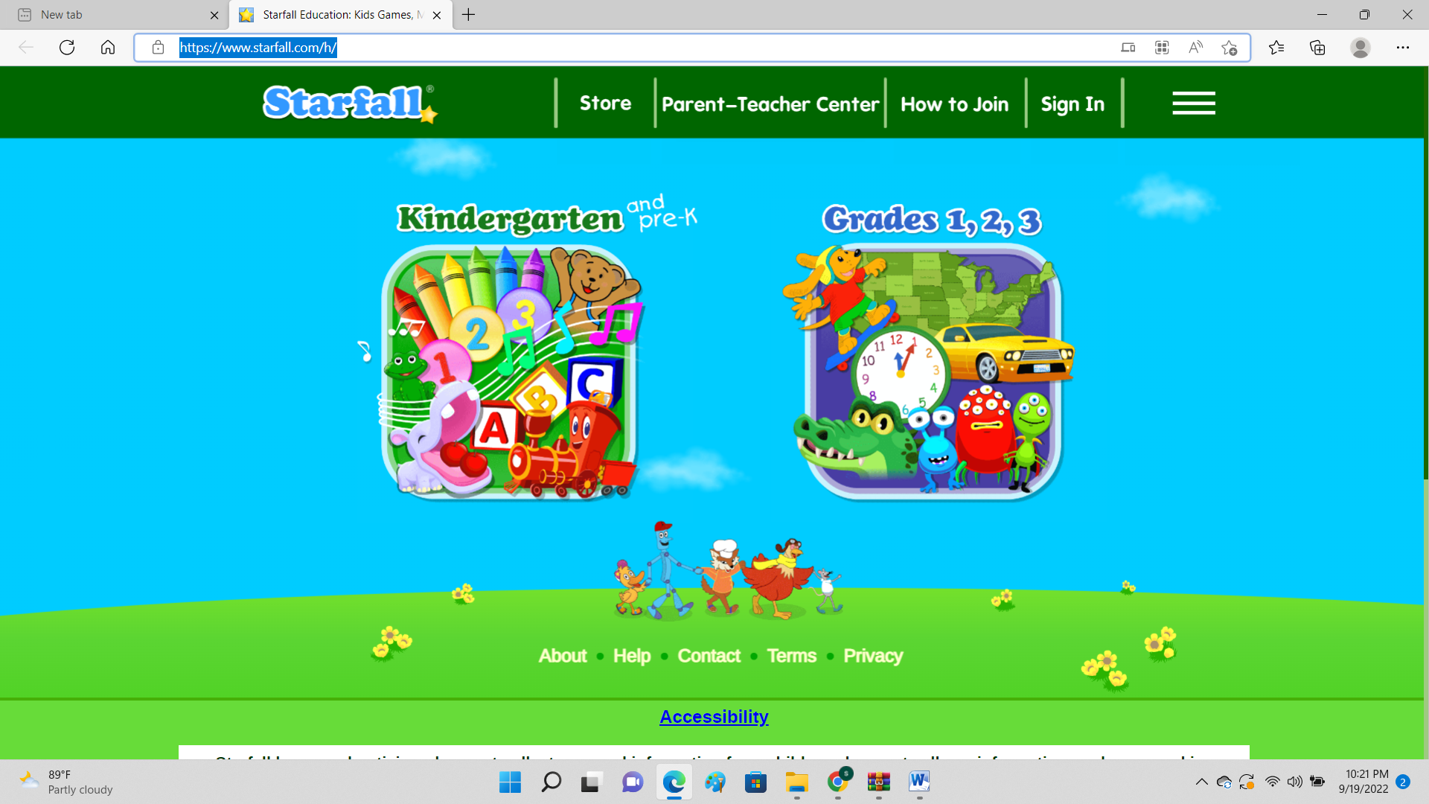

Step 1: Open any browser and type kiddle.co.

Step 2: Type **starfall** in the search bar.

Step 3: Click on the links to web pages. The links are the blue words.

Step 4: Students will choose their favourite activity from the given list.

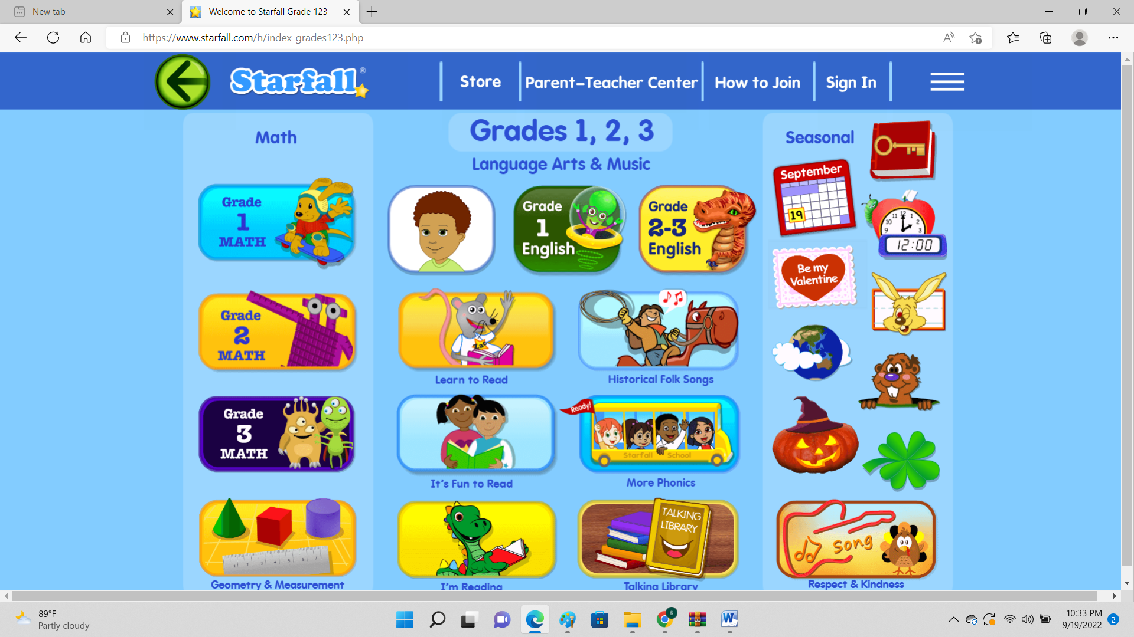

 .

Step 5: Use the backward button to go back to the previous page.

Step 6: Use the forward button to go to the next page.

Step 7: Close the page.