1. Find the interquartile range
2. 2, 3, 4, 5, 5, 5, 6, 6, 7, 7, 8, 8, 9, 10
3. 5, 1, 3, 2, 2, 4, 1, 6, 1, 0
4. a) This cuboid has a square cross-section.  
   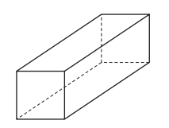

Write down the number of planes of symmetry.

(b) This cuboid has a **rectangular** cross-section.  
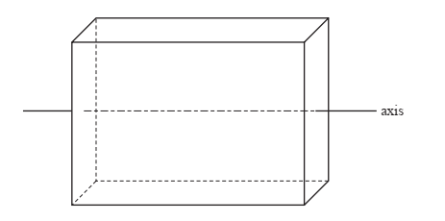

The axis shown passes through the centre of two opposite faces. Write down the order of rotational symmetry of the cuboid about this axis.

1. Show that +can be expressed in the form a, where *a* and *b* are integers
2. Show that = 3
3. Rationalize
4. Rationalize the denominator and simplify fully Show clear working out.
5. The table shows the populations of five countries.

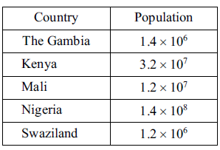

1. Which of these countries has the largest population?
2. Calculate the difference between the population of Kenya and the population of Nigeria. Give your answer in standard form.
3. The population of South Africa is 30 times the population of The Gambia. Calculate the population of South Africa. Give your answer in standard form.

1. Solve 5𝑥−6 > 3(𝑥−1)

1. Solve 7𝑥+6 > 1+2𝑥
2. Solve 3𝑥+5 ≥ 𝑥+17
3. Solve 2𝑦+17 < 6𝑦+5
4. Are the lines with equations and parallel, perpendicular or neither?
5. Find the gradients of the following lines:
6. Write down the th term of the linear sequence

Hence, write down the th term of the quadratic sequence.

1. On the grid, draw the graph of *y* = 2*x* + 3 for values of *x* from .–2 to 4

|  |  |  |  |  |  |  |  |
| --- | --- | --- | --- | --- | --- | --- | --- |
| x | -2 | -1 | 0 | 1 | 2 | 3 | 4 |
| y |  |  |  |  |  |  |  |

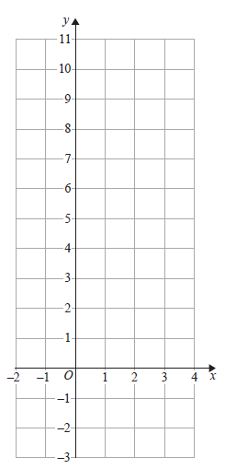

Show, by shading on the grid, the region that satisfies **all three** of the inequalities

*x*≤ 3 and *y* ≥ 2 and *y* ≤ 2*x* + 3

Label your region **R**.

1. Find the equation of the line which is perpendicular to and passes through the point .
2. Determine the gradient of the line with equation .
3. Find the midpoint of and .

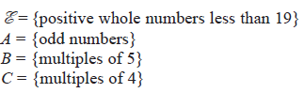

(a) List the members of the set

(i) *A* ꓵ *B*

(ii) *B* Ս *C*

(b) Is it true that *B* ꓵ *D* = ɸ

1. Katy has 5 white flowers, x red flowers and 2x+1 yellow flowers. She picks a flower at random. The probability that it is white is . Find the probability that it is yellow.
2. Solve 33x × = 3
3. Two fair spinners are spun. Spinner 1 has four equal sections labelled 1, 3, 4 and 5. Spinner 2 has three equal sections labelled 5, 6 and 7.

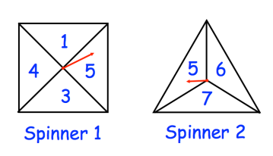

Each spinner is spun once. The numbers are added together to get a score.

(a) Complete the table to show all possible scores.

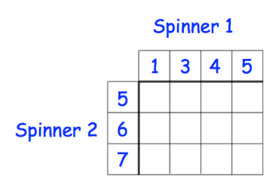

(b) Find the probability of scoring a 8 .........................

(c) Find the probability of scoring an odd number

1. 3× = 3n ,Find the value of n
2. Simplify
3. (3x 2 y) 3
4. (2t –3 ) –2
5. **Rearrange the following formula making the subject**











1. Make b as subject

C=

1. Evaluate the following
2. Show that

.