MARKING SCHEME
1a  b  c  d | Modem  Router  Switch  NIC | 1  1  1  1
2 | Four from:  - Stores IP addresses  - IP address is a unique identifier set up by network manager/ISP  - Can change but should match the network it’s on  - IP address consists of 4 numbers separated by full stops  - Stores MAC addresses  - 6 pairs of hexadecimal digits  - MAC address is usually hard coded by manufacturer, never changes | 4
3a  b |     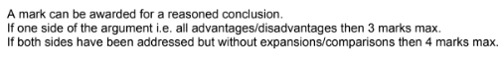 | 2  6
4 | 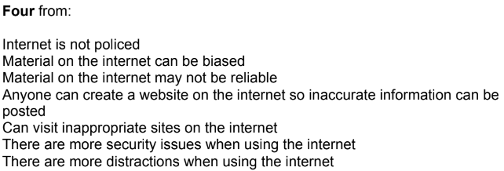 | 4
5 | 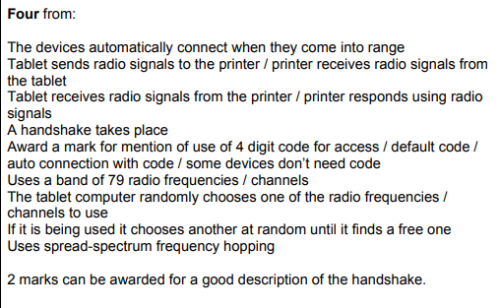 | 4
6 | 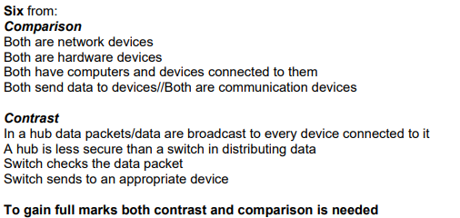 | 6

