Read and comprehend the questions.

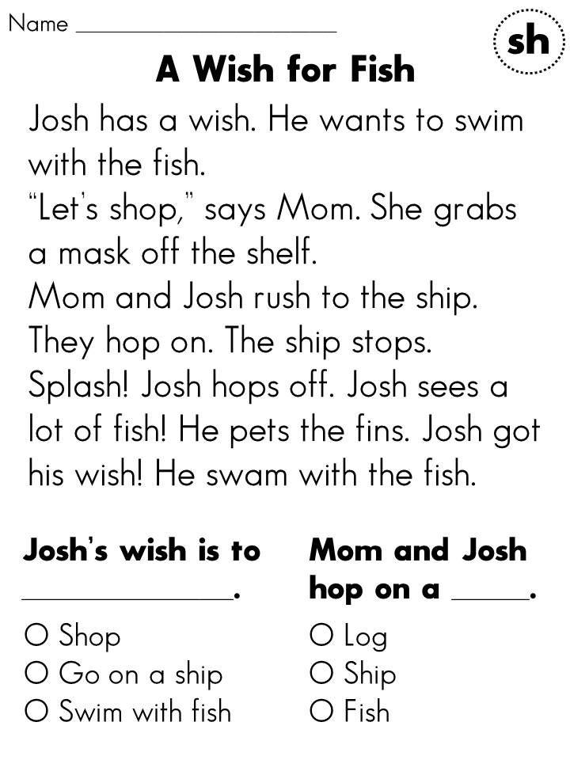

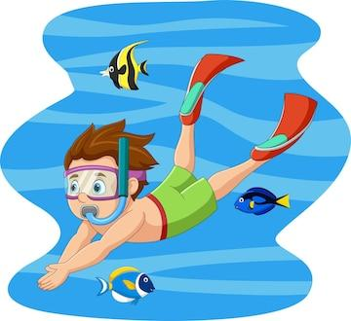

1) Josh’s wish is to …………………………………………………………..

2) Mom and Josh hop on a ……………………………………………..

3) What did Josh see in the sea?

……………………………………………………………………………………………………….

4) Did Josh happy about his wish? ..........................................

5) Write one sentence about a **fish.** Remember to use capital letter and full stop.

………………………………………………………………………………………………………

(Total 5X2= 10 marks)