(10 marks)

Unit 4.1 Human organs

Think like a scientist 1: Exercise and heart rate

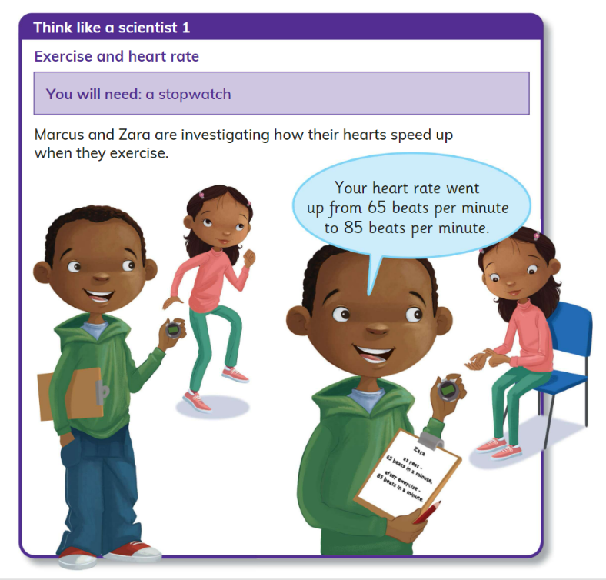

/6

1. Record your observations in the following bar chart.

2. What was your heart rate before the exercise?

/1

/1

3. What was your heart rate after exercise?

___________________________________________________________________________

/1

4. What was your heart rate after two minutes of rest?

__________________________________________________________________________

5. The bar chart shows a pattern. Do you think the same pattern always happens when you exercise and then stop?

/1

_________________________________________________________________________

**Self-reflection criteria:**

* I can present results using a table after having investigated through hands-on experiment.
* I can record information in a table.
* I can interpret the results using the table.
* I can make a conclusion from results.
* I can make predictions and see if they were right.