Quiz 2 - MS
Computer Modelling
Question | Answer | Marks
1 a  b | 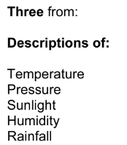  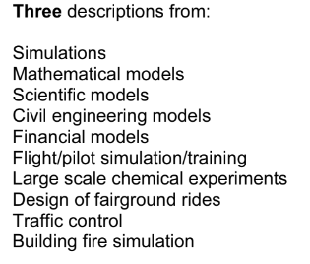 | 3  3
2 | 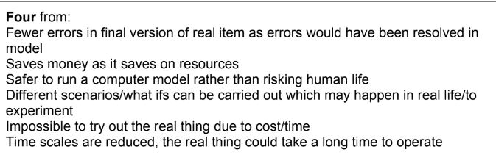 | 4

