1. An antique vase was bought for $300 and sold for $375. Calculate the profit percentage

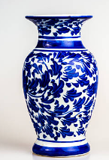

1. A bicycle is sold for $180, resulting in a 15% loss. Find the original cost price.

