1. (a) The chemical equation can be represented as shown.

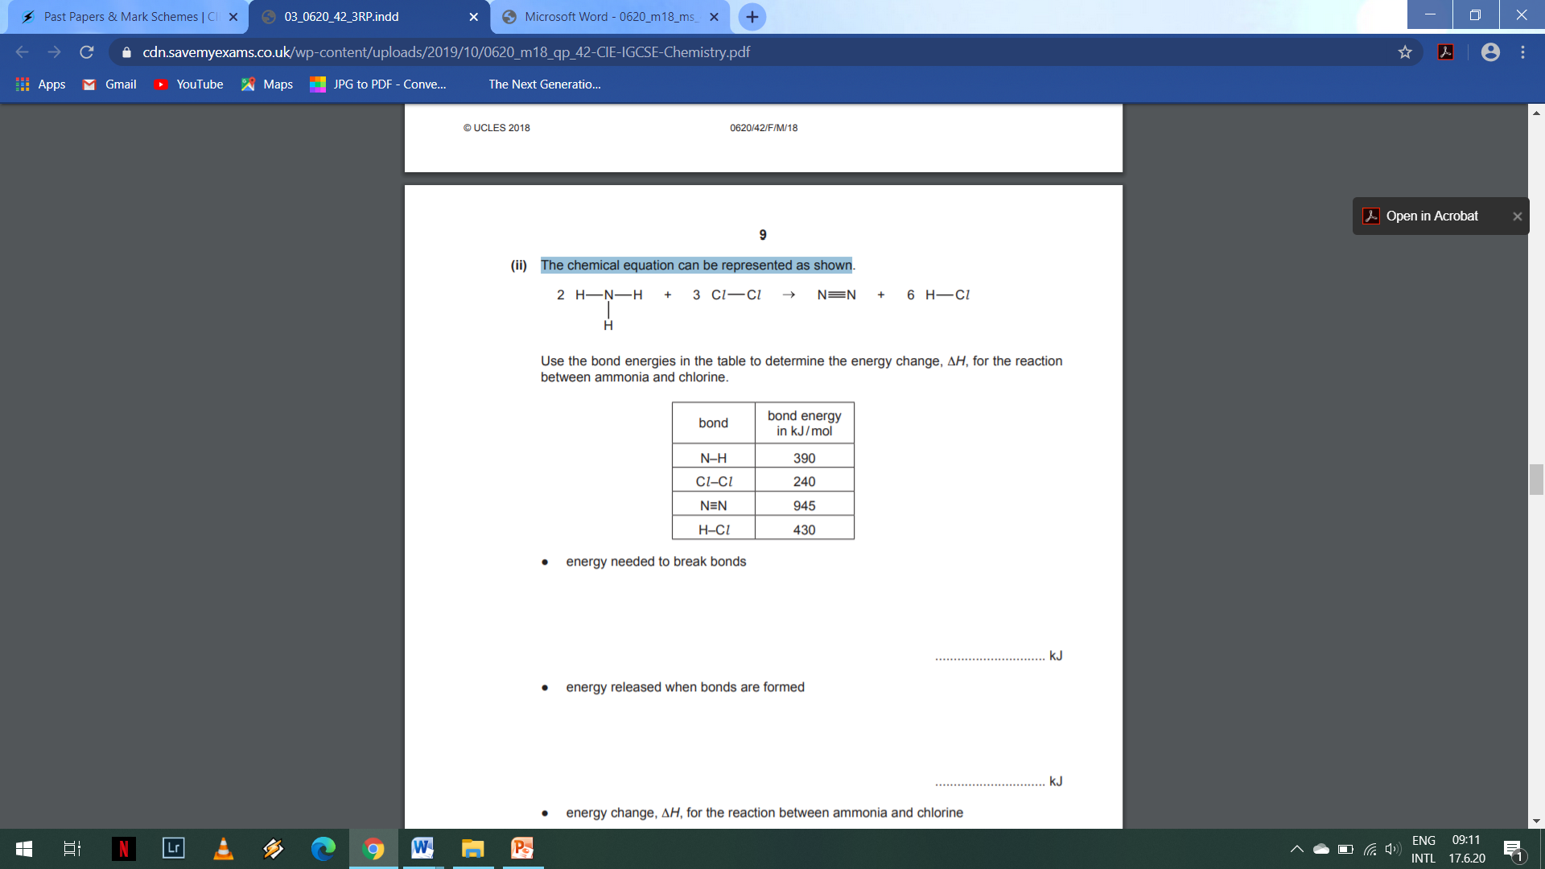

Use the bond energies in the table to determine the energy change, ΔH, for the reaction between ammonia and chlorine.

|  |  |
| --- | --- |
| Bond | Energy/ kJ per mol |
| N-H | 390 |
| C*l*-C*l* | 240 |
|  | 945 |
| H-C*l* | 430 |

* energy needed to break bonds

.............................. kJ

* energy released when bonds are formed

.............................. kJ

* energy change, ΔH, for the reaction between ammonia and chlorine

.............................. kJ

(b) Is the reaction endothermic or exothermic? Explain your answer. ................................................................................................................................................................................................................ .......................................................................................................................................

c)Draw energy level diagram for the above reaction

1. Some chemical reactions are reversible.
2. Aqueous potassium chromate(VI), K2CrO4, is a yellow solution.

Aqueous potassium dichromate(VI), K2Cr2O7, is an orange solution.

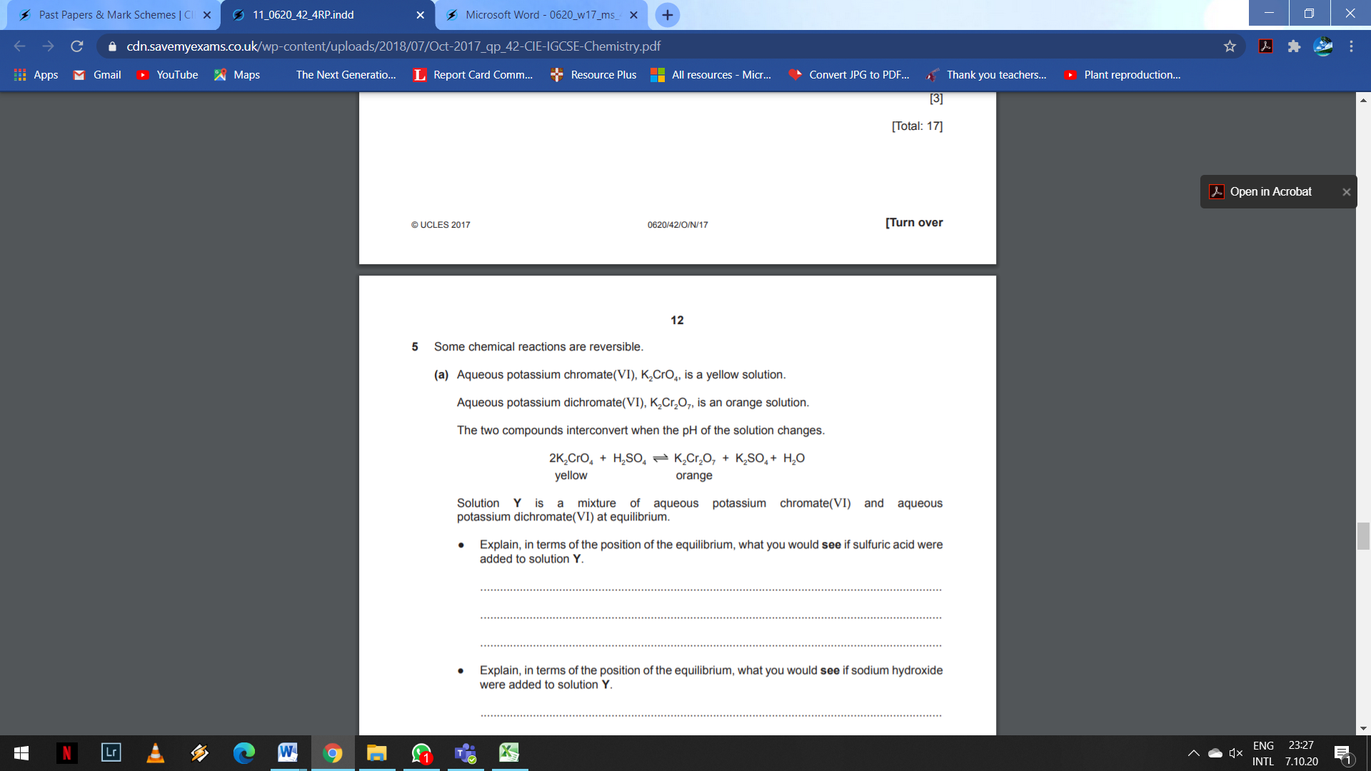

Solution Y is a mixture of aqueous potassium chromate (VI) and aqueous potassium dichromate (VI) at equilibrium.

● Explain, in terms of the position of the equilibrium, what you would see if sulfuric acid were added to solution Y

........................................................................................................................................................................ ........................................................................................................................................................................ ....................................................................................................................................................................

1. Hydrogen can be manufactured using a reversible reaction between methane and steam.

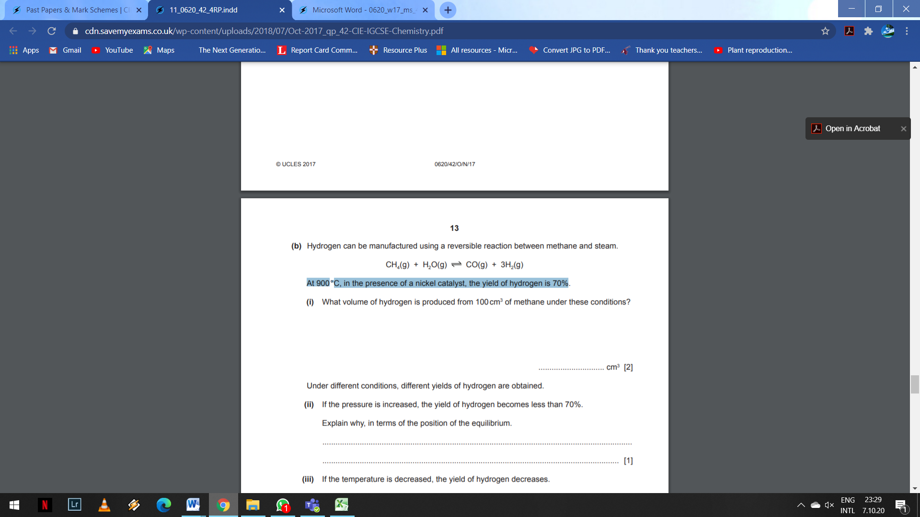

At 900°C, in the presence of a nickel catalyst, the yield of hydrogen is 70%.

Under different conditions, different yields of hydrogen are obtained.

1. If the pressure is increased, the yield of hydrogen becomes less than 70%. Explain why, in terms of the position of the equilibrium. ................................................................................................................................................................................... ..............................................................................................................................................................................
2. If the temperature is decreased, the yield of hydrogen decreases. What does this information indicate about the reaction between methane and steam? ...........................................................................................................................................................
3. Why is a catalyst used in this reaction? ...........................................................................................................................................................

3. Hydrogen peroxide decomposes to form water and oxygen. This reaction is catalysed by manganese(IV) oxide.

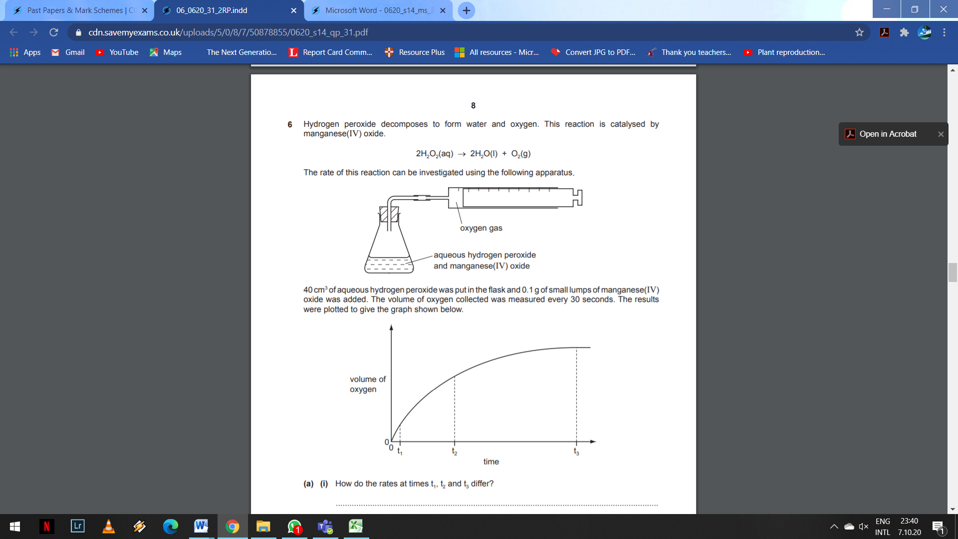

The rate of this reaction can be investigated using the following apparatus.



40 cm3 of aqueous hydrogen peroxide was put in the fl ask and 0.1 g of small lumps of manganese(IV) oxide was added. The volume of oxygen collected was measured every 30 seconds. The results were plotted to give the graph shown below.



1. (i) How do the rates at times t1, t2 and t3 differ? ...................................,,,,,,,,,,,,,,,,,,,,,,,,,,,,,,,,,,,,,,,,,,,,,,,,,,,.......................................................................................................... .......................................................................................................................................

(ii) Explain the trend in reaction rate that you described in (a)(i). ................................................................................................................................................................................................ ............................................................................................................................................................................................... .........................................................................................................................................................................................

1. The experiment was repeated using 0.1 g of finely powdered manganese (IV) oxide. All the other variables were kept the same.
2. On the axes opposite, sketch the graph that would be expected.
3. Explain the shape of this graph.

...................................................................................................................................................................... ………………............................................................................................................................................. ...................................................................................................................................................................... ................................................................................................................................................................