1. Match the picture with correct category of the animal: /6

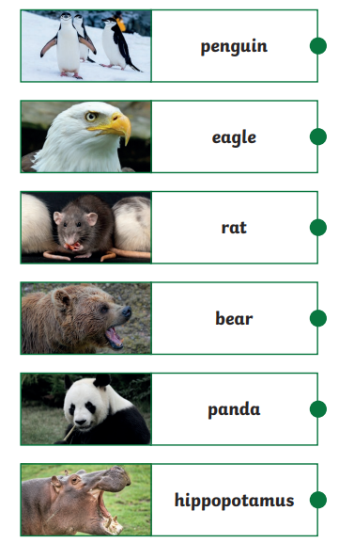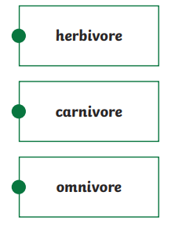

1. Read the question carefully and circle the answer: /4

1. What do herbivores eat?  
 a) Meat  
 b) Plants  
 c) Both meat and plants

2. What do omnivores eat?  
 a) Only meat  
 b) Only plants  
 c) Both meat and plants

3. If an animal eats both berries and small animals, what kind of eater is it?  
 a) Herbivore  
 b) Carnivore  
 c) Omnivore

4. Why do carnivores have sharp teeth?  
 a) To help them chew grass  
 b) To help them catch and eat meat  
 c) To swim faster in water