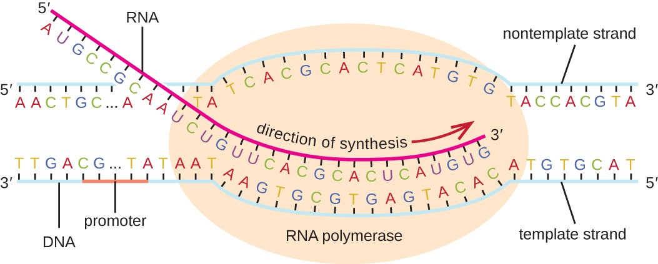

Transcription

* happens in the __________

Translation

* converting a code in the __________ into a _________ takes place at the ____________

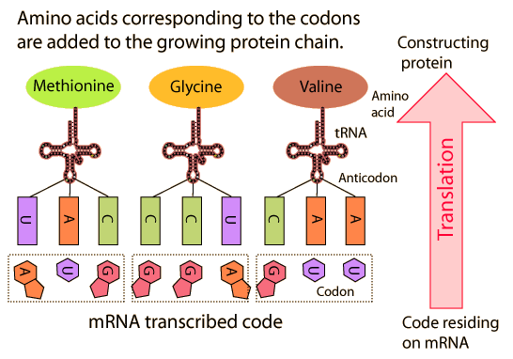

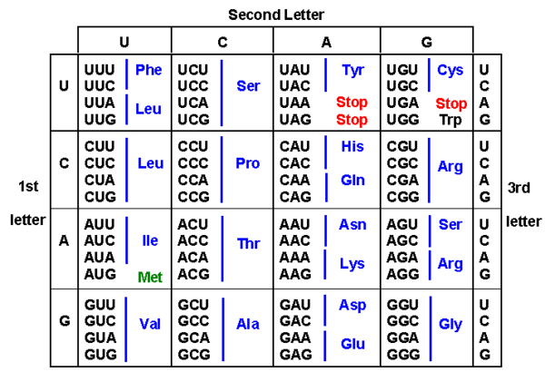

Give the summary of protein synthesis.

……………………………………………………………………………………………………………………………………………………………………………………………………………………………………………………………………………………………………………………………………………………………………………………………………………………………………………………………………………………………………

…………………………………………………………………………………………………………………………………………………………………………………………………………………………………………………

…………………………………………………………………………………………………………………………………………………………………………………………………………………………………………………

…………………………………………………………………………………………………………………………………………………………………………………………………………………………………………………

…………………………………………………………………………………………………………………………………………………………………………………………………………………………………………………