Sum of interior angle of a triangle is ………………………………………………………….

1. Consider the following figure

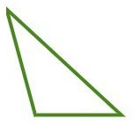

Name of the shape : ………………………………………

Can we draw the diagonals (which should not intersect) for the given shape ? Yes No

How many such diagonals are there :

If possible draw the diagonals

Sum of interior angles :

1. Now consider the given shape

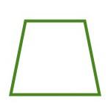

Name of the shape : ………………………………………

Can we draw the diagonals (which should not intersect ) for the given shape ? Yes No

How many such diagonals are there :

**If possible draw the diagonals**

**How many triangles are so formed**

Sum of interior angles :

1. Now consider the given shape

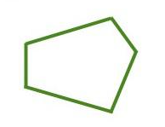

Name of the shape : ………………………………………

Can we draw the diagonals (which should not intersect ) for the given shape ? Yes No

How many such diagonals are there :

**If possible draw the diagonals**

**How many triangles are so formed**

Sum of interior angles :

1. Now consider the given shape

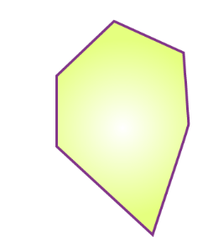

Name of the shape : ………………………………………

Can we draw the diagonals (which should not intersect ) for the given shape ? Yes No

How many such diagonals are there :

**If possible draw the diagonals**

**How many triangles are so formed**

Sum of interior angles :

Now complete the table

**Now complete the following table**

|  |  |  |  |
| --- | --- | --- | --- |
| Name of the shapes | Number of sides | Number of triangles formed | Sum of interior angles |
|  |  |  |  |
|  |  |  |  |
|  |  |  |  |
|  |  |  |  |
| Heptagon | 7 |  |  |
| Octagon | 8 |  |  |
| Nonagon | 9 |  |  |
| Decagon | 10 |  |  |
| A polygon | **n** |  |  |