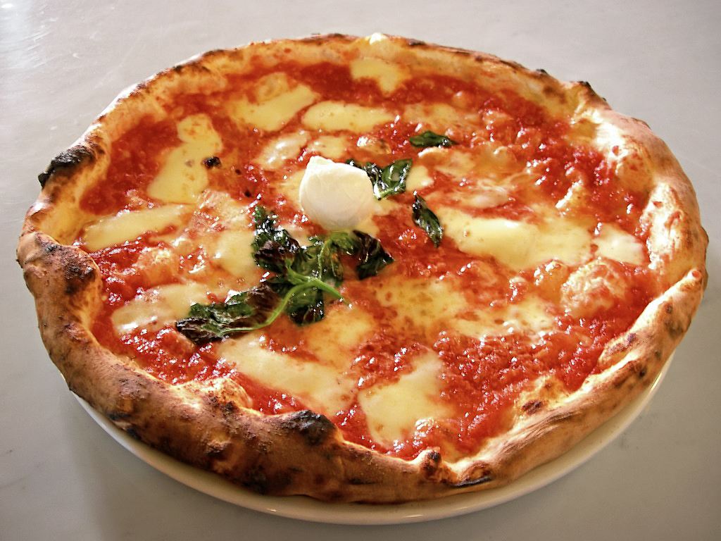
Description 1
Imagine a cheesy, saucy, warm bread melting in your mouth. What is this delightful food?
Its nothing more than pizza. Pizza pie is one of the most popular foods in America it can be
found everywhere. It is a staple of the American diet as a cheap and easy meal. Pizza is sold in
many shapes and variations from barbeque on pizza to chocolate chips. Pizza is served at parties,
in cafeterias and in college dorms. Not only has pizza pie make its way into American culture. It
has now become American as apple pie. From the discovery by royalty in Italy, and through
European immigration it made its way to American culture.

Description 2
Pizza, dish of Italian origin consisting of a flattened disk of bread dough topped with some combination of olive oil, oregano, tomato, olives, mozzarella or other cheese, and many other ingredients, baked quickly—usually, in a commercial setting, using a wood-fired oven heated to a very high temperature—and served hot ...

Description 3
Mr. Pizza got the shock of his life as his cheese filled tears left a scrub on his pepperoni face. The mushroom knew the hurt he felt due to the charcoal color of his feet.

