ANSWER KEY

1. H2O2(l) H2O(l)  + O2(g)

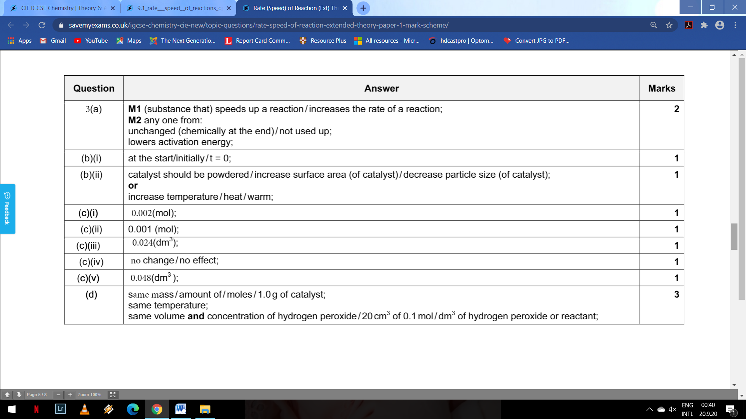





Extended Task:

Answer at page 188-189 of coursebook