# I. Choose the right answer. [5]

|  |  |  |  |  |  |
| --- | --- | --- | --- | --- | --- |
| **Server** | **Cipher text** | **Information** | **Hacker** | **Sharing** | **Key** |

1. Network failure may prevent the police officer from _________ information from __________. /1
2. An encryption ______________is coded.is the secret that explains how a message. /1
3. Encryption helps to safely exchange data between web _______and browser. /1
4. It works by replacing each plain text letter with a new letter and one of the oldest method of encryption is known as ______________ . /1
5. __________ often steal personal information for financial gain. /1

# II. State whether the statement is true or false. [5]

6. The Caesar cipher can be used to encrypt messages.

7. Encrypted data is commonly referred to as plain text.

8. Encryption is used to ensure that emails sent over a network are protected from unauthorised persons.

9. The Caesar cipher is also known as a substitution cipher.

10.Pigpen cipher does not involve replacing the letter with the symbols.

# IV. Answer the following. [10]

10. Sameer is working as a doctor in a Hamad hospital, he keeps a track the other doctor details and patience details via online. If the network fails then what are the effects the doctor will face? /2

_____________________________________________________________________

_____________________________________________________________________

_____________________________________________________________________

_____________________________________________________________________

_____________________________________________________________________

_____________________________________________________________________

11.Shalini is working in an IT company, she needs to send a secrete message via email to her manager related to the work. Can you help her to choose the between the Caesar and pigpen cipher text techniques?

Differentiate between the Caesar and pigpen encryption. /3

|  |  |
| --- | --- |
| **Caesar Cipher Text** | **Pigpen Cipher Text** |
|  |  |
|  |  |
|  |  |

12. Encrypt and decrypt the letter/sentences/words with the pigeon encryption techniques. /3

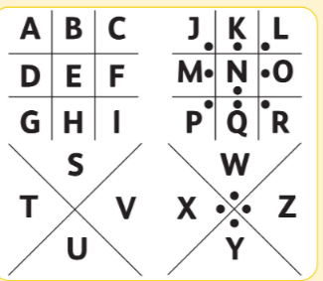

a) Which pigpen symbol would be used to represent the following letters/words.

|  |  |  |  |  |  |
| --- | --- | --- | --- | --- | --- |
| HI | C | K | Z | O | TNG |
|  |  |  |  |  |  |

b) Decode the following; /2

A B C D E F G H I J K L M N O P Q R S T U V W X Y Z

|  |  |  |  |  |  |  |  |  |  |  |  |
| --- | --- | --- | --- | --- | --- | --- | --- | --- | --- | --- | --- |
| I |  | L | O | V | E |  | Q | A | T | A | R |
|  |  |  |  |  |  |  |  |  |  |  |  |

Use -Key 4



_________________________________________________________________________

_________________________________________________________________________