- Answer The following:
- Define:
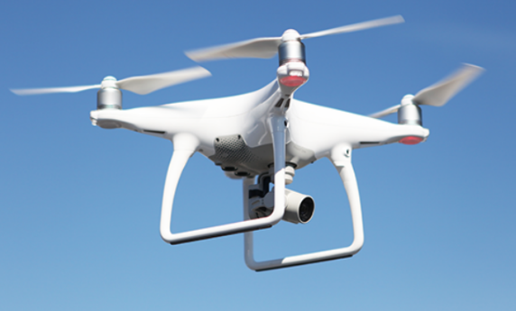
- sara once spotted a small flying object hovering in the sky. It was not a bird, and it was making a buzzing sound. Sarah wanted to know more about it and decided to investigate. Her friend told her that it was a drone. however, she is still confused. help sara to understand what a drone is?
____________________________________________________________________________________________________________________________
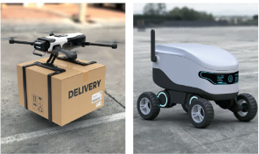
- Jake was at a grocery store and saw the automatic doors opening as he approached them. He wondered how they detected his presence. He learnt that it is because of sensors? can you explain what is a sensor? give one example.
____________________________________________________________________________________________________________________________
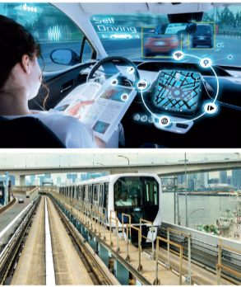

- How are robots helpful in the following fields:
a. Delivery: ________________________________________________________________________________________________________________________________________________________________________________________________________________________________________________________________________________________________________________________________
b. Transportation:
________________________________________________________________________________________________________________________________________________________________________________________________________________________________________________________________________________________________________________________________
c. Food service industry:
________________________________________________________________________________________________________________________________________________________________________________________________
________________________________________________________________________________________________________________________________

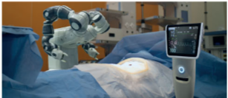
d. Healthcare:
________________________________________________________________________________________________________________________________________________________________________________________________________________________________________________________________________________________________________________________________

