Quiz
12.3 Transforming shapes

- Look at the following diagram and describe fully the single transformation that maps one shape on to another.

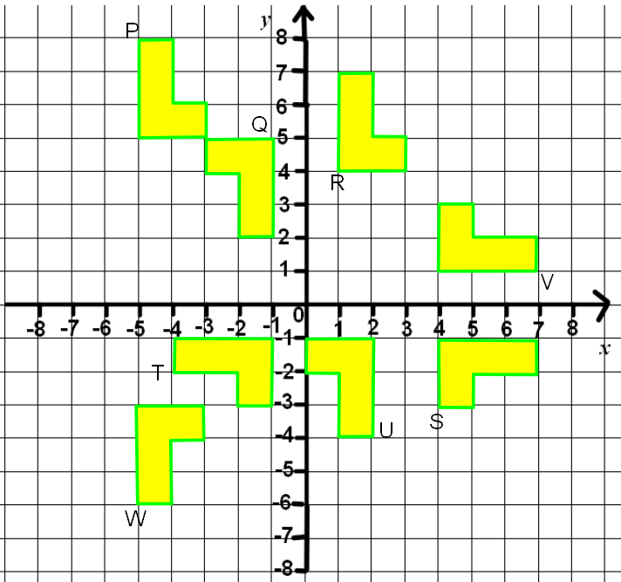

P to Q…………………………………………………………………………………

………………………………………………………………………………………….

P to R…………………………………………………………………………………

………………………………………………………………………………………….

U to Q…………………………………………………………………………………

………………………………………………………………………………………….

V to S …………………………………………………………………………………

………………………………………………………………………………………….

R to V …………………………………………………………………………………

………………………………………………………………………………………….

(5)

- Triangle P is drawn on a coordinate grid. (5)
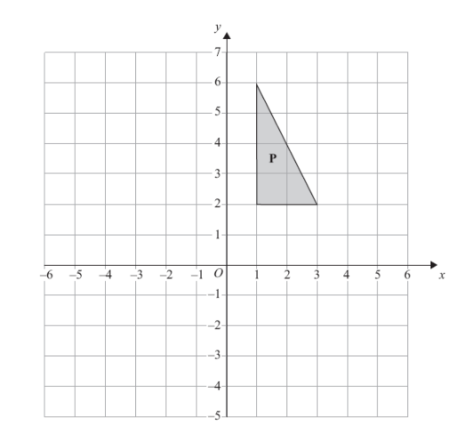

The triangle P is reflected in the line x = –1 and then reflected in the line y = 1 to give triangle Q.
Describe fully the single transformation which maps triangle P onto triangle Q.

………………………………………………………………………………………

………………………………………………………………………………………

