

Formal Formative 2

1. **Write down one word that matches each of these descriptions: /5**

a a well-balanced soil

_________________________________________________________________________

b a fossil where the bones of the whole animal are preserved in minerals

_________________________________________________________________________

c to wear down weathered rock into sediments

_________________________________________________________________________

d the feel of a material

_________________________________________________________________________

e a natural fertiliser made of dead organic matter such as dead leaves and insects.

_________________________________________________________________________

1. **Decide whether each of the following statements is true or false. /4**

Write ‘True’ or ‘False’ in the answer spaces.

a Metamorphic rocks form when existing rocks are changed by heat and/or pressure. _______________

b Fossils are the remains of plants and animals preserved in igneous rocks. _______________

c The most important feature of sedimentary rocks is that they are one colour ____________

d A geologist is a scientist who studies rocks. _______________

1. **The below picture shows a rock. /4**

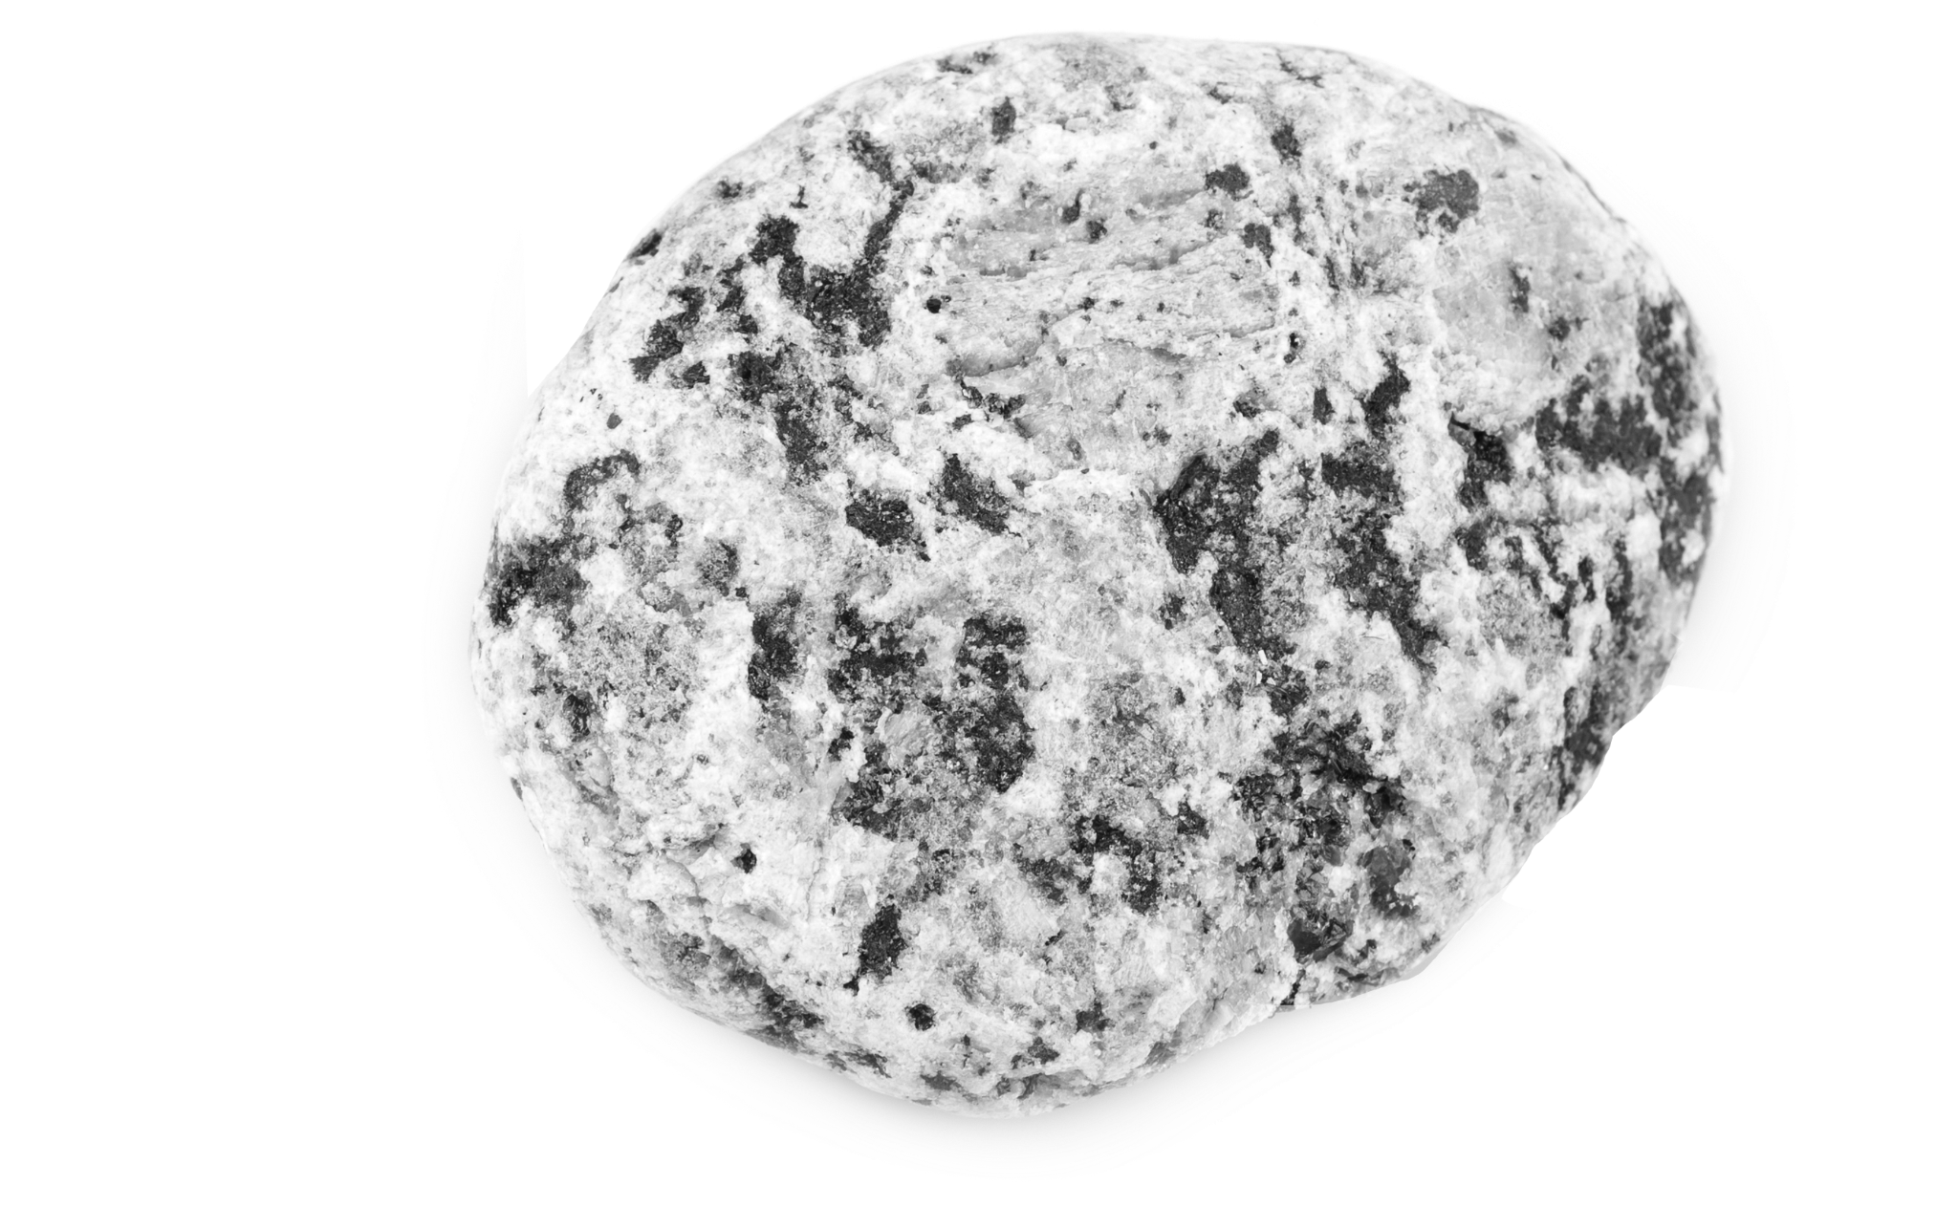

a What does this rock consist of?

_________________________________________________________________________

b Did this rock form when magma cooled down or when lava cooled down?

_________________________________________________________________________

c How do you know that this is an intrusive igneous rock?

_________________________________________________________________________

_________________________________________________________________________

d Identify the rock.

_________________________________________________________________________

1. **This is a sea animal preserved in rock. /2**

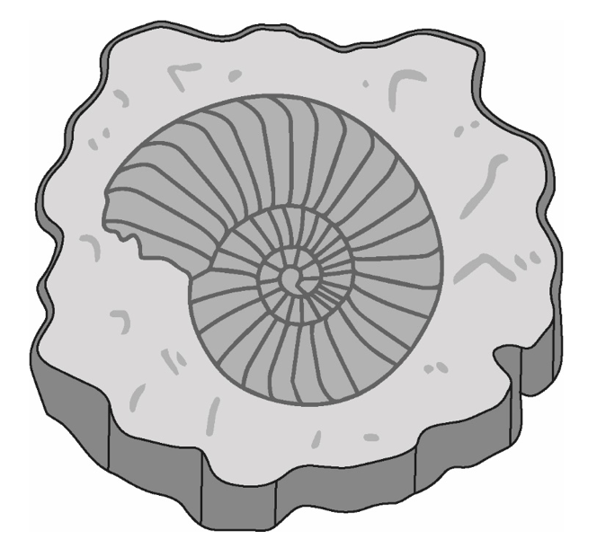

1. **What do we call plants and animals preserved in rock?**

**______________________________________________________________________________**

**b Was this animal ever alive?**

**______________________________________________________________________________**

1. **The below diagram shows rock cycle. /6**

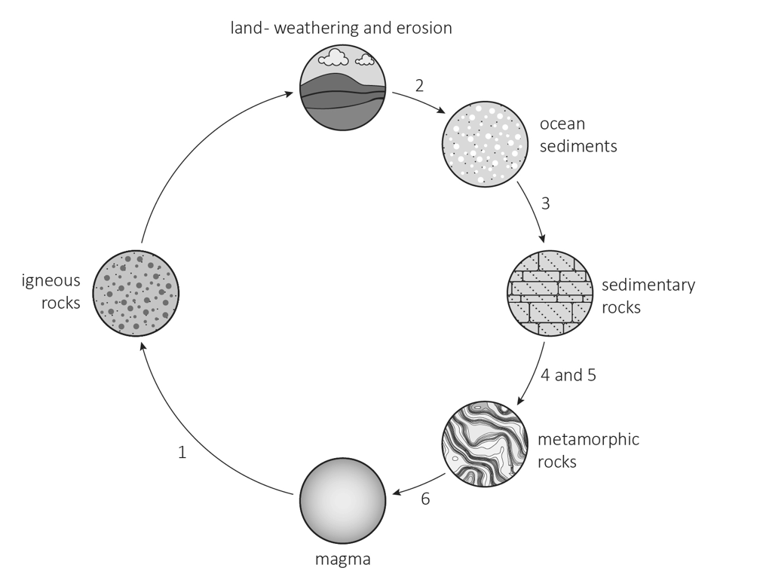

a Name the process at 1: _______________

b Name the process at 2: _______________

c Name the process at 3: _______________

d Name the process at 4: _______________

e Name the process at 5: _______________

f Name the process at 6: _______________

1. **There are three types of rock found on the Earth’s surface. One of the types of rock is called sedimentary.**
2. Name the other two types of rock. /1

___________________________________________________________________________________________

1. Look at the table. It shows the description of some rocks.

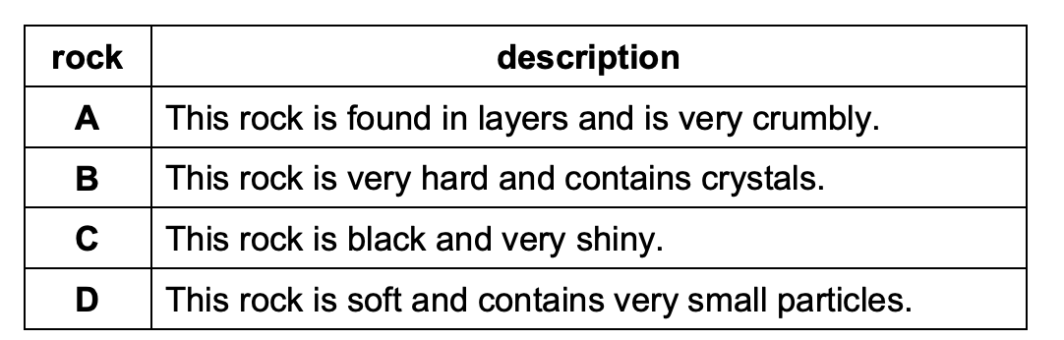

Which two rocks are sedimentary? /1

___________________________________________________________________________________________

1. Aiko finds this fossil in some sedimentary rock.

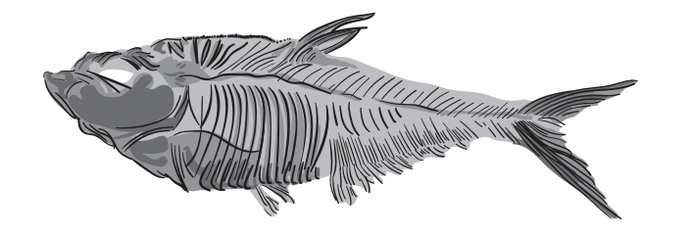

Describe how fossils are formed in sedimentary rock. /2

___________________________________________________________________________________________

___________________________________________________________________________________________

___________________________________________________________________________________________

___________________________________________________________________________________________