**Work in pairs.**

Have you heard of Siri@ or Alexa? You may have heard someone on their

phone say "Siri@, what's the weather like today?" • or "Alexa, play music."

Alexa and Siri@ are digital voice assistants. They can control devices that are connected to the internet.

Cut out and sort the devices below that Siri or Alexa can control?

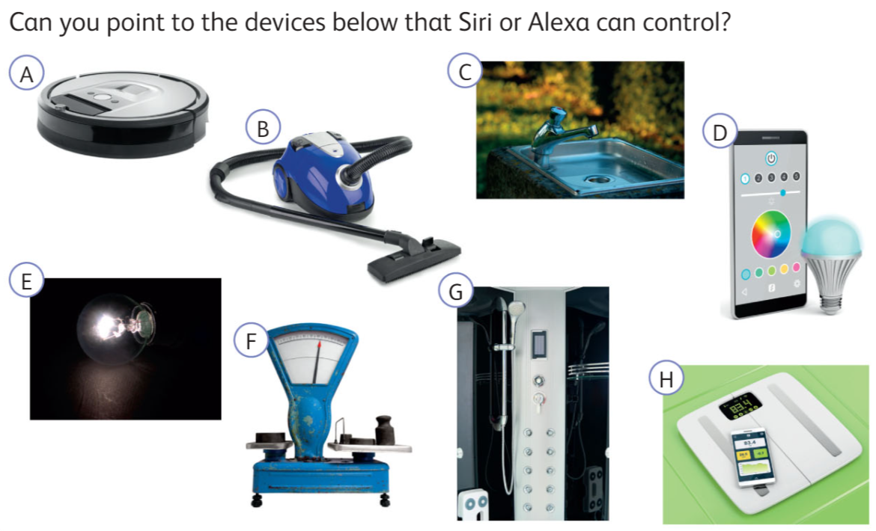

|  |  |
| --- | --- |
| **Devices assisted by Alexa or Siri** | **Devices not assisted by Alexa or Siri** |
|  |  |