**Databases**

**Question 1:**

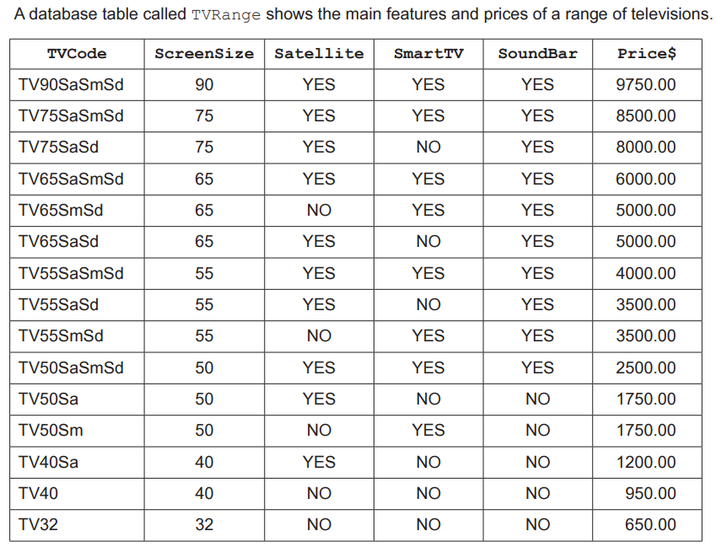

**Question 2:**

[2]