Quiz 6
Data analysis
Question | Answer | Marks
- a | 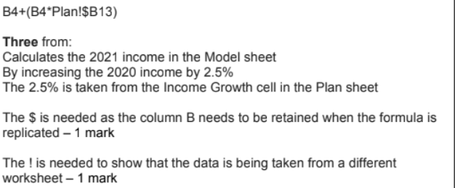 | 5
b | 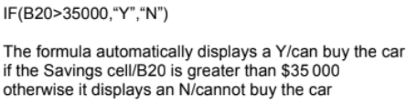 | 3
2 | 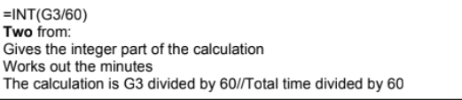 | 2

