**QUIZ-6 (GRADED)**

**Data Analysis**

1. Khalid keeps a spreadsheet to record his expenses and to plan for future spending. This

spreadsheet is split into two separate sheets, which he has named Plan and Model.

Plan contains details of his future spending.

Model contains a model of his income and expenses.

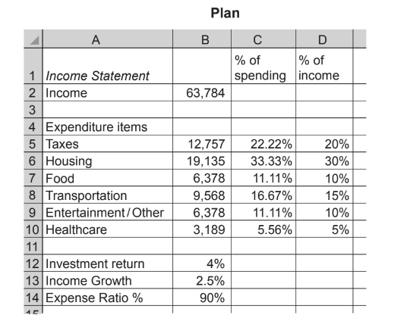

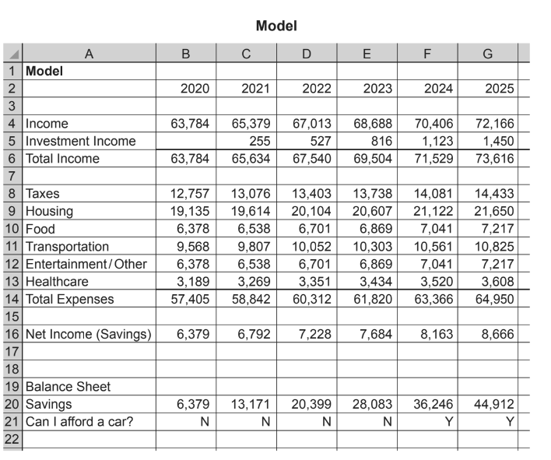

1. Khalid has entered a formula in cell C4 of the Model sheet. The formula is B4+(B4*Plan!$B13)

Explain, in detail, what the formula does. Include in your answer an explanation of why the $ and the ! are used in the formula. [5]

………………………………………………………………………………………………………………………………………………………………………………………………………………………………………………………………………………………………………….

………………………………………………………………………………………………………………………………………………………………………………………………………………………………………………………………………………………………………….

………………………………………………………………………………………………………………………………………………………………………………………………………………………………………………………………………………………………………….

………………………………………………………………………………………………………………………………………………………………………………………………………………………………………………………………………………………………………….

……………………………………………………………………………………………………………………………………………………

1. He is saving up to buy a new car; this will cost at least $35,000. Khalid has entered a formula in cell B21 of the Model sheet. The formula is IF(B20>35000,"Y","N").

Explain, in detail, what the formula does. [3]

………………………………………………………………………………………………………………………………………………………………………………………………………………………………………………………………………………………………………….

………………………………………………………………………………………………………………………………………………………………………………………………………………………………………………………………………………………………………….

1. A spreadsheet has been produced showing the final places in one of the events in the 2018 Winter Olympic Games.

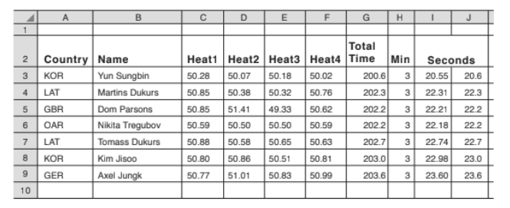

The event consists of four heats. The times taken to complete each heat are added together to

give the Total Time, in seconds. This is then displayed as minutes and seconds.

Two formulae form this calculation; they are stored in column H and column J.

The formula in cell H3 is: =INT(G3/60)

(a) Explain what the formula in cell H3 does. [2]

…………………………………………………………………………………………………………………………………………………………………………………………………………………………………………………………………………………………………………………………………………………………………………………………………………………………………………………………………………………………………………………………………………………………………………………………………………………….