1. Draw and label a plant: The words in the box will help you. /5



1. **Match the vocabulary with the correct definitions. /5**

| Change | A vegetable that grows underground |
| --- | --- |
| Water | Helping a potato grow little shoots before planting |
| Chitting | The part that holds the plant in the soil. |
| Roots | To become different in some way. |
| Potato | A liquid that plants, animals, and people need to live. |

1. **Use the words in the box to label the pictures: /2**



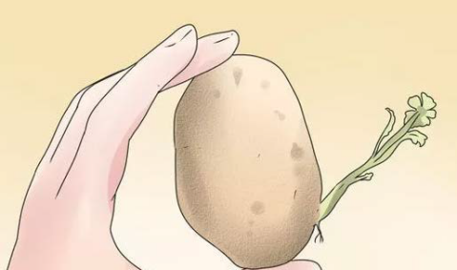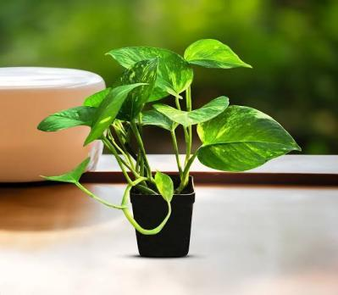



1. Circle the things we use to plant chitted potatoes: /2

**Bags salt soil fruit**

1. Answer True or False to the following statements: /4
2. We can make chips with potatoes. 
3. Cucumber is a type of fruit. 
4. Potatoes are unhealthy. 
5. Plants can be found outside. 
6. Imagine you are a little helper at a grocery store! Your job is to sort the fruits and vegetables into the right baskets so the customers can find what they need. Can you help organize these items?" /2

**apple cabbage strawberry carrot**

Fruits Vegetables

