1. Bacteria are classified as belonging to the Prokaryote kingdom.

(a) State two features of all prokaryotes.

1 ................................................................................................................................................

1. .............................................................................................................................................

[2]

MRSA is a type of bacterium that is resistant to antibiotics. The number of cases of MRSA

identified in hospitals in the USA between 1995 and 2005 was recorded.

Fig. 2.1 shows these data

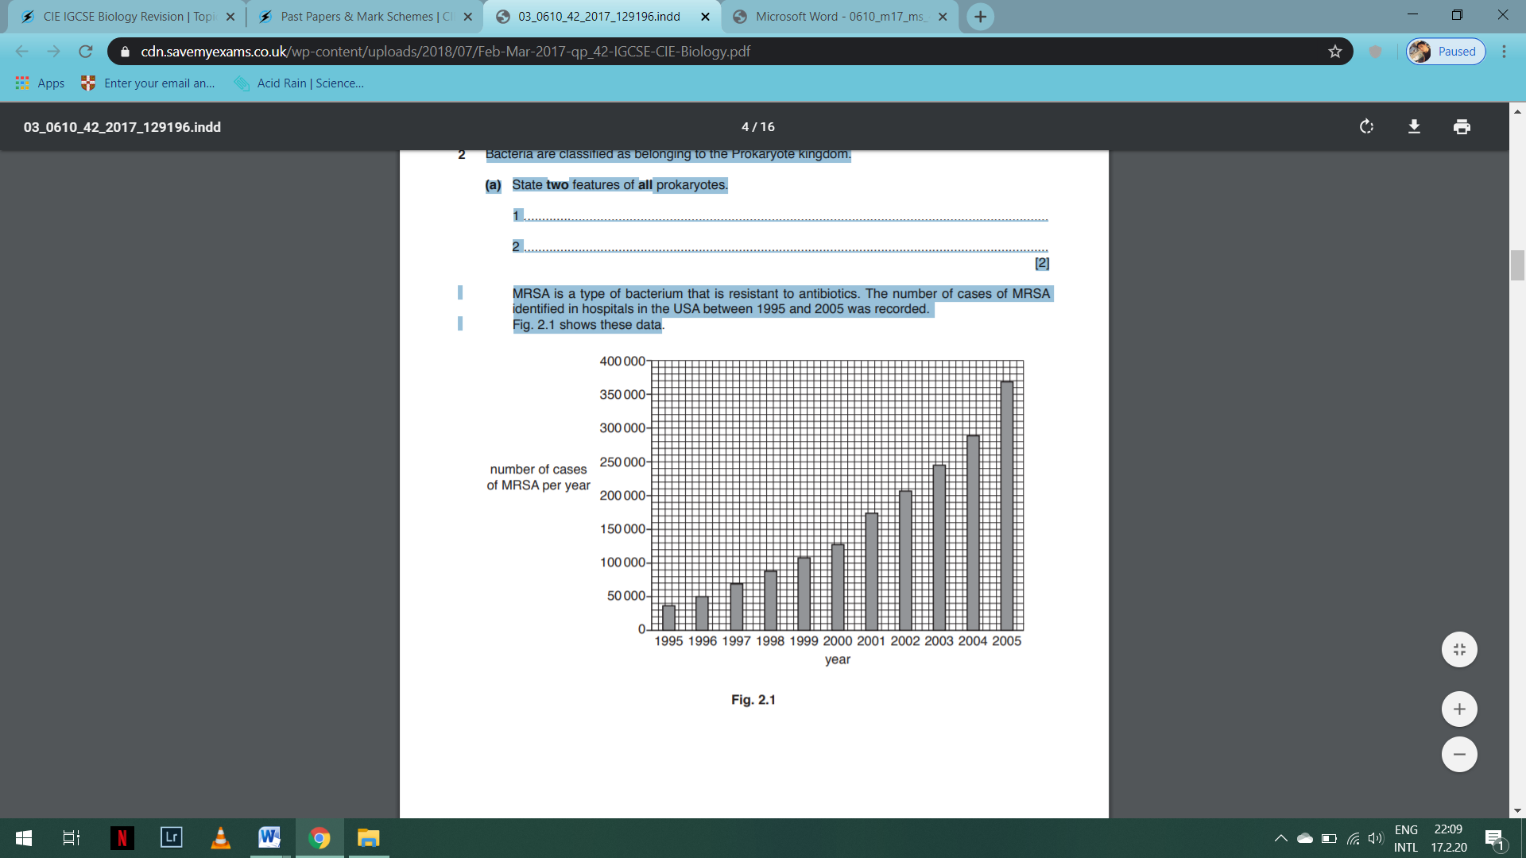

(b) (i) Describe the results shown in Fig. 2.1. ........................................................................................................................................... ........................................................................................................................................... ........................................................................................................................................... ........................................................................................................................................... .......................................................................................................................................[2]

(ii) Explain how bacteria become resistant to antibiotics. ........................................................................................................................................... ........................................................................................................................................... ........................................................................................................................................... ........................................................................................................................................... ........................................................................................................................................... ........................................................................................................................................... ........................................................................................................................................... ........................................................................................................................................... .......................................................................................................................................[4]

(c) The number of cases of MRSA has decreased since 2005. Suggest reasons for this decrease. ................................................................................................................................................... ................................................................................................................................................... ................................................................................................................................................... ................................................................................................................................................... ...............................................................................................................................................[2]

[Total: 10]