**I) TASK A: Find some facts about Fruits.**

# 

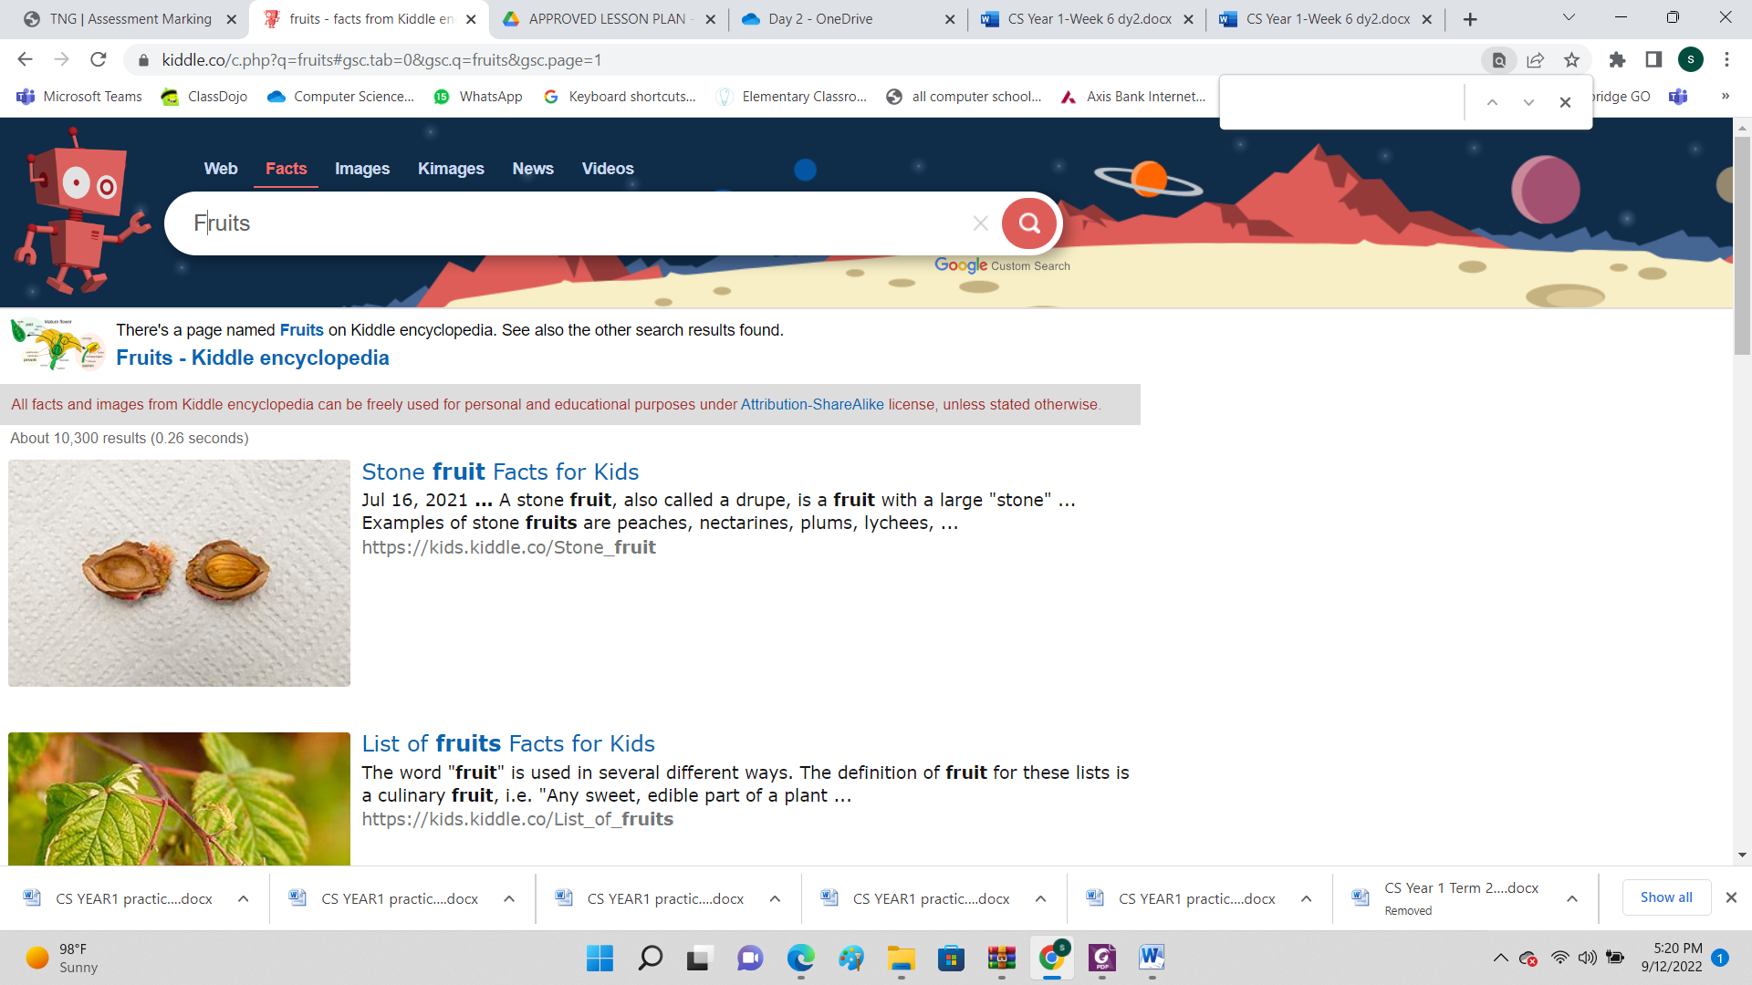

* 1. Open **Kiddle** search engine.
  2. In the search box type “fruits” and find some facts about fruits.
  3. Find about facts about your favorite fruit :

# **Use a hyperlink**

* + - **Use forward and backward icons**
  1. Scroll the webpage up and down.
  2. Close Kiddle.

1. **Create a program for sunset.**
2. Open **Scratchjr**.
3. Add the sprite sun .
4. Convert the algorithm into a Scratch program.

|  |
| --- |
| **Algorithm for sun** |
|  |

1. Run the program.